Next ASC is Sunday June 11, 2017 at 10:00 AM
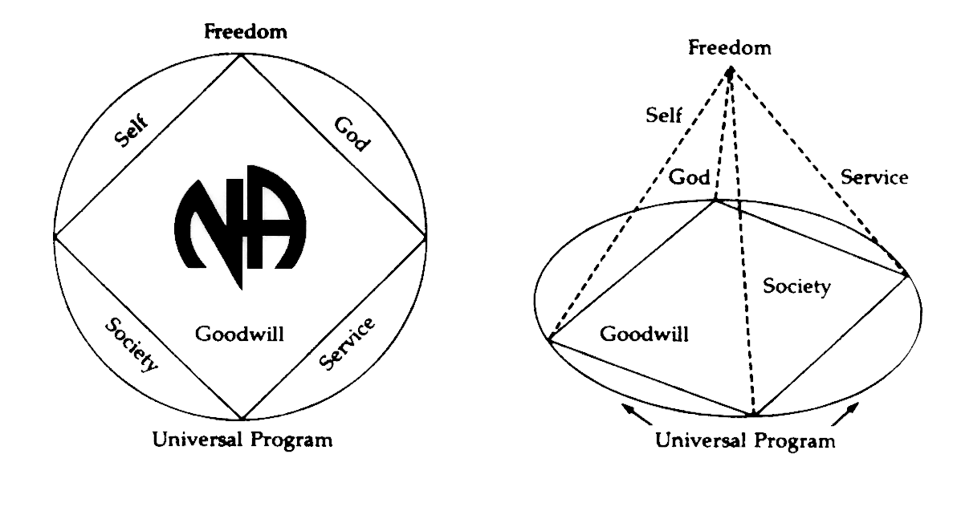
THERE WILL BE A
NEW GSR ORIENTATION BEGINNING AT 9:30am

GSRS
PLEASE ANNOUNCE THE FOLLOWING AT YOUR MEETINGS:
WE NEED TRUSTED SERVANTS AT THE AREA LEVEL

ACTIVITIES TREASURER
NEWSLETTER CHAIR
POLICY CHAIR
ACTIVITIES CHAIR
ALTERNATE SECRETARY

Any questions or suggestions:

James S. (Chair): Southersjames122014@gmail.com 754-204-5494
Dan (Vice Chair): Forabetterlook@aol.com 954-931-3703
Horacio M. (Treasurer): Horacio.f.moreno@att.net 954-479-9447
Ashley C. (Secretary): SBAreaSecretary@gmail.com 954-551-5687
Liz S. (RCM): e.southers@outlook.com 754-208-7024

South Broward Area ASC Minutes
Dan opened the meeting at 10:00am with the Serenity Prayer.
Marc read the Twelve Traditions.
Melody read ASC Definition.
Open Forum- [All thoughts and opinions expressed in open forum are that of the individual and do NOT represent NA as a whole]
Joanne: I have raffle tickets to win a weekend package for SFRCNA next year. Come see me if your interested. They are $10.00.

Ralph – New GSR for Hold on Pain Ends
Maxine – New GSR 24-Hour Solutions
Miguel – New GSR Conscious Contact
James- New GSR Sunrise Serenity
Marc- New GSR Back to Life We Live
Patrick- New Alternate GSR 12 O’clock High Group

Roll Call
ADMIN COMMITTEE | Mar | Apr | May | ADMIN COMMITTEE | Mar | Apr | May
Chair: James S |  |  |  | H&I Chair: Duke S
754-204-5494 | X | X | O | 954-931-7083 | X | X | O
Southersjames122014@gmail.com |  |  |  | dukehlwd@yahoo.com
Vice Chair: Dan F  954-931-3703  Forabetterlook@aol.com |  |  | X | Literature Chair: Morgan F  321-207-6054  Frankrebel2011@hotmail.com | X | X | X
Secretary: Ashley C |  |  |  | Policy Chair:
954-551-5687 | X | X | X
AshleyCandelmo@gmail.com |  |  |  | Open Position
Alternate Secretary: |  |  |  | Activities Chair:
Open Position |  |  |  | Open Position
Treasurer: Horacio M |  |  |  | Activities Treasurer:
954-479-9447 | X | X | X |  | O | O | O
Horacio.f.moreno@att.net |  |  |  | Open Position
Alternate Treasurer: Barry |  |  |  | Helpline/PR Chair: Tony  786-800-7178
954-298-5971 | O | X | X | recol1@aol.com | X | X | X
na51998@aol.com
RCM: Liz S |  |  |  | Newsletter Chair:
754-208-7024 | O | X | X
e.southers@outlook.com |  |  |  | Open Position
Alternate RCM:
Open Position

# | Group |  |  | Mar | April | May
1 | 10 PM Recovery |  |  | X | X | X
2 | 12 O’clock High Group |  |  | X | X | X
3 | 24 Hour Solutions |  |  | O | X | X
4 | A Day at a Time |  |  | O | X | X
5 | Conscious Contact |  |  | N/A | N/A | X
6 | Back to Life We Live |  |  | X | X | X
7 | Bitter Ends |  |  | O | X | X
8 | Boys to Men |  |  | O | X | X
9 | Double Trouble |  |  | X | X | X
10 | Feminine Principles |  |  | X | X | X
11 | Free to Choose |  |  | X | X | X
12 | Fridays on Foster |  |  | O | O | X
13 | Hollywood Monday Night |  |  | X | X | O
14 | HO.P.E. |  |  | X | O | X
15 | I Can’t We Can |  |  | X | X | X
16 | Journey Begins |  |  | X | X | X
17 | Let Go, Let God |  |  | X | X | X
18 | Negative Thoughts, Positive Reactions |  |  | X | X | X
19 | No Rezervations |  |  | X | X | X
20 | One Step At a Time |  |  | N/A | N/A | X
21 | Road to Freedom |  |  | X | X | X
22 | Spiritual Awakenings |  |  | X | X | X
23 | Step It Up |  |  | X | X | X
24 | Sunset Recovery |  |  |  | X | X
25 | Take a Break |  |  | X | X | X
26 | Veterans in Recovery |  |  | X | X | X
27 | Women’s Group |  |  | X | X | X
 | 28.Sunrise recovery  29. We have a choice |  |  | N/A  O | N/A  O | X  X
Attendance Key: |  | X = Present | O = Absent
Three consecutive absences from one group will result in being deleted from roll call.
Quorum is Established at (1/2 of 27+1)=15

Present 28 of 29 = Quorum Met

4. Reading of the second to last paragraph of Prefix of the Basic Text: Rafael
5. Trusted Servants Presentations by: James
6. Acceptance of last month’s Minutes by: Sunset Recovery

7. Administrative Reports:

ASC Chair Report: James S – Dan F was sitting in for James as Active Chair. No report at this time.

ASC Vice-Chair: Dan F was elected today. No report at this time.

Secretary: Ashley C – Ashley, Addict. I am passing around a notebook for all groups. Please add your group name and email so I can account for all groups when I send out the minutes. Also, last month several sub committee chairs did not respond to my emails, calls, or txt messages when I requested their report. In the future if you refuse to submit a report to me I will document that in the minutes. Thank you.

RCM: Liz S. –
SFRCNA fundraisers have all been doing very well.
Motion for SFRCNA 2017 budget passed.
Rental Car motion from the Bahamas area was tabled for clarification and sent back to groups this month to vote on.
Motion went out from the SFRCNA BOD to redefine the regional zones.
ATTACHED ARE THE RSC MINUTES AND THE MOTIONS REFERRED TO ASC. (See attached minutes)
Alternate RCM: – open position

SUBCOMITTEE REPORTS

Activities Chair: – open position
Dan F gave Activities report as Vice Chair of Area- Activities met on 4/27 and 5/11, an inventory was taken, committee has made a motion to change locks for accountability. Keys have been distributed. Next meeting is Thursday night.

Activities Treasurer -open position

Helpline/PR Chair: Steve–
Greetings from your Helpline/Public Relations Subcommittee. We met twice since the April ASC, once on April 20 and again on May 18. Of our current membership of 13, we had 8 in attendance at each meeting. All the available Additional Needs Guidelines from the region have been reviewed and distributed to all members in attendance. Discussions on how and where to inquire for help with Additional Needs resources will be held over our next several subcommittee meetings. We reviewed our one box phone billing statement, and the volume of calls will be part of our ASC report each month. We discussed devoting a portion of our meeting reviewing the volume and nature of our helpline calls, and how each member handles them. Copies of our emergency contact list and Helpline Orientation Information was given to all members present. We will be producing a business card with our local helpline number soon. All helpline shifts are currently covered. From March 28 through April 27 we received approximately 72 calls for a live person. Our Secretary had to step down from her position. Vice Chair will cover position until further notice. We would like to encourage some female participation in our subcommittee. We currently do not have any women attending our monthly meetings. We meet the third Thursday of each month At Faith Christian Church 7676 Davie Road Extension at 7:15. Hope to see some new members at our next meeting. Any questions regarding the Additional Needs Guidelines can contact Steven at 954 588 0785. In loving Service Tony and Steven.

H&I Chair: Duke – Ryan W (Vice H&I Chair) filled in for Duke and read the following report written by Duke:
Good Morning Folks, I’m an addict and my name is Duke. As you can see I am not here today and Ryan will be giving this report. Ryan is the Vice- Chair and has been all year. First, I put in a check request of $15 for rent. We had 9 voting members in attendance on Tuesday. We filled 3 open spots. We had one chair covering each week so we got someone to fill alternate weeks with him. We had two addicts filling an open spot until someone stepped up and someone did on Tuesday now those spots are covered. We had someone step down from their commitment just this week and another member filled that position the next day. I am very grateful for the willingness. There will be a member stepping away for a time so he could spend time with his elderly mother. We have a facility at the South Florida State Hospital that is difficult to fill. There are not many addicts in that group but we have been bringing meetings in there for over 20 years. If anyone would like to bring a meeting into this institution please show up at our subcommittee meeting. I’d like to say thank you to our H&I members. We meet the 3rd Tuesday of each month. Please join us. Make sure everyone meets Ryan before you run out. Ryan will be our nomination for H&I chair in July.

Treasurer: Horacio M – Please see attachment for report

Alternate Treasurer: - Nothing to report.

Policy Chair: – open position

Literature Chair: Morgan- Morgan Addict, We didn’t spend any money this month. Like I said last month if we owe something you need to bring back the form with my initials on it so I can see proof that we owe something. (See attached invoice for 5/16/17)

GSR’S – GROUPS MUST VOTE ON NOMINATIONS & MOTIONS

NEW BUSINESS –

Always Hope is no longer a meeting.

Nominations & Elections-
Max was nominated for policy chair of area, he qualified by meeting clean time requirement, service requirement, step work, business experience, and reported high willingness to be of service.

Lynne was nominated for treasurer of activities, she qualified by meeting clean time requirement, service requirement, has a bank account and reported high willingness to be of service.

Area Motions: - None at this time
Motion
Maker: Second:
Motion:
Intent:

Motion
Maker: Second:
Motion:

Motion:
Maker: Second:
Motion:
Intent:

Regional Motions-

SEE ATTATCHMENTS

OLD BUSINESS –

Dan was nominated for vice chair of area, he qualified by meeting clean time requirement, service requirement, and reported high willingness to be of service. Motion Passed
Motion 20170402 passed
Motion: 20170403 passed

Regional Motions- None

Motion to Close: Let Go Let God
Seconded: All

