Next ASC is Sunday October 9, 2016 at 10:00 AM
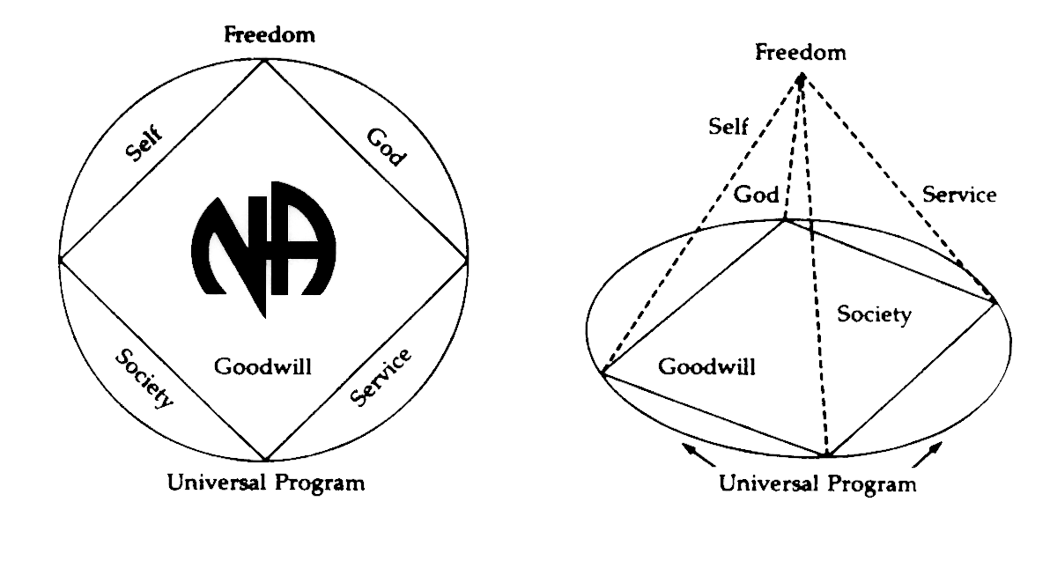
THERE WILL BE A
NEW GSR ORIENTATION BEGINNING AT 9:30am

PLEASE ANNOUNCE THE FOLLOWING AT YOUR MEETINGS:
WE NEED TRUSTED SERVANTS AT THE AREA LEVEL

ALTERNATE TREASURER
ALTERNATE RCM
ACTIVITIES TREASURER
NEWSLETTER CHAIR
POLICY CHAIR

Any questions or suggestions:
James S. (Chair): Southersjames122014@gmail.com/754-204-5494
Horacio M. (Alternate Treasurer): Horacio.f.moreno@att.net/954-479-9447
Robert S. (Vice-Chair): robertstuart5611@yahoo.com/954-483-9147
Sandy D. (Secretary): SBAreaSecretary@gmail.com/954-253-7578
Rachel B. (Alternate Secretary): Rayluvsty2985@gmail.com/954-867-8911
South Broward Area ASC Minutes
James S opened the meeting at 10:00am with the Serenity Prayer.
Ralphie read the Twelve Traditions.
Tony read ASC Definition.

Open Forum- [All thoughts and opinions expressed in open forum are that of the individual and do NOT represent NA as a whole]

ALL NEW GSRs BELOW:
Dave – I am from Annapolis, Maryland representing 10pm Recovery
Frank – Fridays on Foster
Larry – Bitter Ends Group - Davie
Ralphie – Let Go, Let God
Mike – Veterans in Recovery Group – do not have to be a Veteran to be a part of this group

Roll Call
Admin Committee | AUG | SEPT | OCT | Admin Committee | AUG | SEPT | OCT
Chair: James S  754-204-5494  Southersjames122014@gmail.com | X | X |  | H&I Chair: Duke S  954-931-7083  dukehlwd@yahoo.com | X | X
Vice Chair: Robert S  954-483-9147  robertstuart5611@yahoo.com | X | X |  | Literature Chair: Morgan F  321-207-6054  Frankrebel2011@hotmail.com | X | X
Secretary: Sandy D  954-253-7578  Sdeen1124@gmail.com | X | X |  | Policy Chair:  Open Position | O | O
Alternate Secretary: Rachel B  954-867-8911  Rayluvsty2985@gmail.com | X | O |  | Activities Chair: Clint  954-614-2146  lynnbupps@gmail.com | X | X
Treasurer: Horacio M  954-479-9447  Horacio.f.moreno@att.net | X | X |  | Activities Treasurer:  Open Position | O | O
Alternate Treasurer:  Open Position | X | O |  | Helpline/PR Chair: Forest  forest@envisionwebdevelopment.com | O | X  Vice-chair
RCM: Liz S  754-208-7024  e.southers@outlook.com | X | X |  | Newsletter Chair:  Open Position | O | O
Alternate RCM:  Open Position | O | O

# | Group | Aug | Sept |  | Oct
1 | 10 PM Recovery | O | X
2 | 12 O’Clock High Group | X | X
3 | Always Hope | O | X
4 | Back to Life We Live | O | X
5 | Beach Recovery | X | X
6 | Day at a Time | X | O
7 | Double Trouble | O | X
8 | Bitter Ends | X | X
9 | Free to Choose | X | O
10 | Fridays on Foster | X | X
11 | Grey Book Group | O | O
12 | H.O.P.E. | X | O
13 | I Can’t We Can | X | X
14 | Journey Begins | X | X
15 | Let Go, Let God | X | X
16 | Negative Thoughts, Positive Reactions | X | O
17 | No Rezervations | X | X
18 | One Step at a Time | X | O
19 | Road to Freedom | X | X
20 | Spiritual Awakenings | X | X
21 | Step It Up | X | O
22 | Sunrise Serenity | O | X
23 | Take a Break | X | X
24 | Tuesday Night Men’s Group | X | X
25 | We Have a Choice | O | O
26 | Women’s Group | X | X
27 | Veterans in Recovery | O | X
Attendance Key: | X = Present | O = Absent
Three consecutive absences from one group will result in being deleted from roll call.
Quorum is Established at 15 (1/2 of 27+1)
Present 19 of 27 = Quorum Met

4. Reading of the second to last paragraph pf Prefix of the Basic Text: Mike
5. Trusted Servants Presentations by: Joann
6. Acceptance of last month’s Minutes by: Veterans in Recovery, Tues Night Men’s Group
7. Administrative Reports:

ASC Chair Report: James S -
It’s been crazy but I am enjoying this. Only thing that I dropped the ball on is updating Policy and printing copies. I had Internet Issues at the house. If you need copies, call me and I will deliver them personally. Other than that, I will have them next month.

I have met with all the chairs and we are working together to better Area as a group.

Chachy, myself and Robert are on the Bank Account now. Thank you for letting me be of service.

ASC Vice-Chair: Robert S -
Welcome to our early time area meeting. Happy to be of service. Remember to cross out all meetings that were meeting at the hope spot from new lists as all meetings there are cancelled.

Secretary: Sandy D – I do not regularly check the South Broward Email for Area. So if you have something that you want sent out or if you need something updated, please send me a text or give me a call and let me know. My number is on the minutes. Thank you.

RCM: Liz S. – Please vote on the Regional Motions under New Business.
Gulf Coast Area created a GSR Workshop Handbook which makes the workshop more interesting. I am wondering what our Policy says if we need any workshops a year. Peace River had 100 people show up to their GSR Workshop which brought a lot of new interest in their area. I think it would be good for us to talk about this as well.

The World Conference is creating a work group for next year for people interested. Looking for themes for convention coming up in Orlando. They are using the Florida Region Human Resources panel to get people involved. Sept 2018. They are look for 1500 volunteers.

Draft to the New Guide to World Service is coming out and we can put out input.

They are talking about making online voting a permanent option.

The World Service Org creating a statement asking groups to not use illicit literature, which is not created by NAWS. We can have input on this also.

The World Board at NAWS looking to downsize the World Service Conference. There are about 100 regions currently and they are looking to change it to zonal seating. For instance, we have 7 votes and we will only have 1 if this happens.

Our region voted Yes to send $30 to the provider for the Bahamas Help Line Services.
We voted Yes to try out different schedules for the RSC weekend.
Admin has a list of all helpline numbers in our region if you are interested. I can send that to you.

Treasurer stated we are $2,719.00 under prudent reserve. We voted for 3 cases of books to be sold at SFRCNA book drive. Duke needs to be at Oct Regional Meeting because they are splitting books up to H&I so we can get free books.

Activities Chair: Clint – Activities will not meet until Oct 13. Meeting list says we are not meeting. It says to contact me, but no one has not contact me, so I do not think anyone cares. We will not have 24 hour rooms this year because we do not have someone from Activities to man the room. Last year it was just me and Mark. Someone who is there has to have a year clean to handle money according to Policy. We try to follow Policy as much as possible. Sometime we screw up, especially me. I won’t be here for Thanksgiving and I may not be here for Christmas either. My mom is 89, so I am going to send as much time with her as possible.
Thanksgiving, I have handed flyers out again. In the Literature, there should be one in there. I posted one here and will do this next month too. It will mostly be a Pot Luck. I am not sure how many turkeys will be donated this year. We need people to serve. See me or Norma.

Activities is going along with last year’s budget with is less then what is on there because rent is cheaper and NA supplies for $500 will be gone because we never buy supplies.

South Atlantic on New Year’s Day usually do breakfast but will not be able to do it this year because there is a wedding scheduled there. It was suggested that our Area let them come here and do it. We are already paying for the room. They will have their own meeting and speaker. I told them I can’t make the decision. I am for it because it will start Unity in our Areas. It’s up to Area what you guys want to do.

Helpline/PR Report: Vice-Chair Tony – helpline doing great. We just put in our budget and we will have enough literature. We have the pancake noon lunch coming up.

H&I Chair: Duke –
We currently have 30 presentations in 9 facilities. The Broward Girls Academy recently closed down. We have 6 open spots. Some of those spots are being covered by the chairs who are covering all the weeks. We are looking for a secretary. We meet the third Tuesday of each month at Luther Memorial Church at 7pm.
Thanks for letting me serve.

Treasurer: Horacio M – No one has been to the P.O. Box for 5 months. I went and there were 5 months’ worth of statements. The old storage was never closed and not we are in collections for $212.12. This could have been avoided if someone checked the box.

In regards to the amount due to collection agency was reduced to $159.09 (this amount is in the report) from $212.12.

Thanks for your service.

(Treasurer’s Report – See next page)

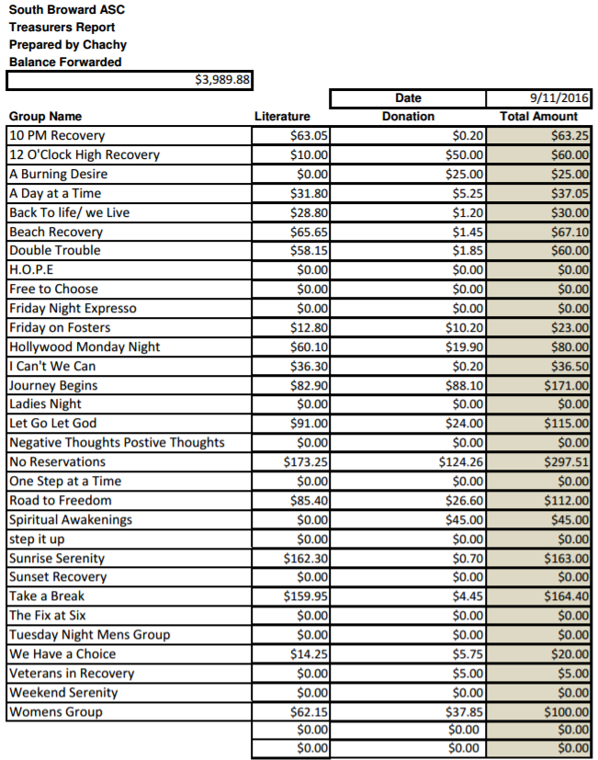
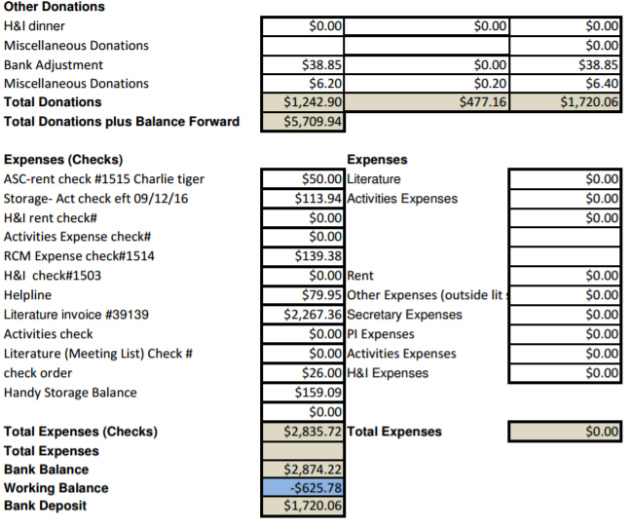

Alternate Treasurer: - open position

Policy Chair: – open position

Literature Chair: Morgan – Lit budget $2000. We went over $267.37. We got a lot of stuff. Mostly pamphlets, books and things we were low on like Medallions. I am trying to get a good order on Medallions. What I see is that people place an order for a Medallion for 5 different groups. Maybe ask them if they asked another home group for the Medallions. I am going to order some stuff for helpline. I will call them and do that separately so it does not take from our stock pile. This month, the meeting lists were free this month because they messed up the order last month. They are not really comparable but we get what we get.

GSR’S – GROUPS MUST VOTE ON NOMINATIONS & MOTIONS

NEW BUSINESS –

Regional Motions-
Maker: RD
Second: None listed
Motion Reads: Revisions to the South Florida Regional Convention of Narcotics Anonymous policy.
Add to the BOD Responsibilities to line 18
18. All members of the BOD and Hosts Committee shall have available current Regional Policy and current SFRCNA Host Guidelines at every meeting. All members of the BOD Admin and Host Admin shall have available Hotel/Venue contracts, Vendor Contracts and Current Budget at every meeting.
Intent: To update Policy for accuracy & accountability.
Financial Impact: None

Maker: RD
Second: None listed
Motion Reads: To change policy on page 4 item E (Format) #18 from "WSC Donation" to "NAWS/SEZF Donations" and on page 6 #10 from "All money motions proposing to send money outside of the Region and not including NAWS donation must be sent back to Areas to be voted on." to "All money motions proposing to send money outside of the Region and not including SEZF/NAWS donation must be sent back to Areas to be voted on."
Intent: To change our RSC Policy to reflect our groups approval of the new zonal guidelines which have now been approved by the zone as a whole and includes our zone being funded by the regions in the Southeastern Zone of which we are a member."
Financial Impact: None

OLD BUSINESS –
PASS - Journey Begins nominated Duke for H&I Chair
PASS - Robert S nominates Clint as Activities Chair

Motion to Close: Mike
Seconded: All

