Next ASC is Sunday September 11, 2016 at 10:00 AM
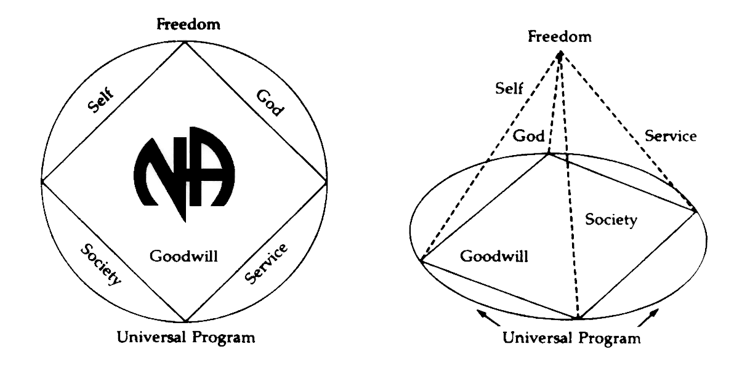
THERE WILL BE A
NEW GSR ORIENTATION BEGINNING AT 9:30am

PLEASE ANNOUNCE THE FOLLOWING AT YOUR MEETINGS:
WE NEED TRUSTED SERVANTS AT THE AREA LEVEL

ALTERNATE TREASURER,
ALTERNATE RCM, POLICY CHAIR,
ACTIVITIES TREASURER
NEWSLETTER CHAIR

Any questions or suggestions:
James S. (Chair): Southersjames122014@gmail.com/754-204-5494
Horacio M. (Treasurer): Horacio.f.moreno@att.net/954-479-9447
Robert S. (Vice-Chair): robertstuart5611@ahoo.com/954-483-9147
Sandy D. (Secretary): SBAreaSecretary@gmail.com/954-253-7578
Rachel B. (Alternate Secretary): Rayluvsty@2985@gmail.com/954-867-8911
South Broward Area ASC Minutes
James S opened the meeting at 12:00 pm with the Serenity Prayer.
Abi read the Twelve Traditions.
Max read ASC Definition.

Open Forum- [All thoughts and opinions expressed in open forum are that of the individual and do NOT represent NA as a whole]
YoFrank – Vice-Chair and other positions in the minutes, said that everyone was acclimated but not that anyone was acclimated my vote. People here serving need to vote because they know if they are doing a good job or not. 2/3 of the Area should have voted.
Ken – I thought we asked for oppositions for the voting.
Allan – One Step at a Step, we had to close one meeting already. It is dismissing and I do not want to see it closed after 33 years. It is at Utopia, please mention it needs support. Tues at 7 pm. June next year speaker who founder

Roll Call
Admin Committee | JUL | AUG | SEPT | Admin Committee | JUL | AUG | SEPT
Chair: James S  754-204-5494  Southersjames122014@gmail.com | X | X |  | H&I Chair: Duke S  954-931-7083  dukehlwd@yahoo.com | O | X
Vice Chair:  Open Position | X | X |  | Literature Chair: Morgan F  321-207-6054  Frankrebel2011@hotmail.com | X | X
Secretary: Sandy D  954-253-7578  Sdeen1124@gmail.com | X | X |  | Policy Chair:  Open Position | O | O
Alternate Secretary: Rachel B  954-867-8911  Rayluvsty@2985@gmail.com | O | X |  | Activities Chair: Clint  954-614-2146  lynnbupps@gmail.com | X | X
Treasurer: Horacio M  954-479-9447  Horacio.f.moreno@att.net | X | X |  | Activities Treasurer:  Open Position | O | O
Alternate Treasurer:  Open Position | X | X |  | Helpline/PR Chair: Forest  forest@envisionwebdevelopment.com | X | O
RCM: Liz S  754-208-7024  e.southers@outlook.com | X | X |  | Newsletter Chair:  Open Position | O | O
Alternate RCM:  Open Position | X | O

# | Group | July | Aug | Sept
1 | 10 PM Recovery | X | O
2 | 12 O’Clock High Group | X | X
3 | Always Hope | O | O
4 | Back to Life We Live | X | O
5 | Beach Recovery | X | X
6 | Burning Desire | O | O
7 | Day at a Time | X | X
8 | Double Trouble | O | O
9 | Free to Choose | X | X
10 | Grey Book Group | X | O
11 | H.O.P.E. | X | X
12 | Hollywood Monday Night | O | O
13 | I Can’t We Can | X | X
14 | Journey Begins | X | X
15 | Ladies Night | X | O
16 | Let Go, Let God | X | X
17 | Negative Thoughts, Positive Reactions | O | X
18 | No Rezervations | X | X
19 | One Step at a Time | O | X
20 | Road to Freedom | X | X
21 | Spiritual Awakenings | X | X
22 | Step It Up | X | X
23 | Sunrise Serenity | X | O
24 | Take a Break | X | X
25 | Tuesday Night Men’s Group | X | X
26 | We Have a Choice | X | O
27 | Women’s Group | X | X
Attendance Key: | X = Present | O = Absent
Three consecutive absences from one group will result in being deleted from roll call.
Quorum is Established at 15 (1/2 of 27+1)
Present 17 of 27 = Quorum Met

4. Reading of the second to last paragraph pf Prefix of the Basic Text: Rob
5. Trusted Servants Presentations by: Liz
6. Acceptance of last month’s Minutes by: Road to Freedom, Let Go Let God
7. Administrative Reports:

ASC Chair Report: James W. -
I checked with Duke and Robert before this meeting and everything is good. Clint said he was never voted on to be Activities Chair. I am going back through the minutes to check on that. Morgan and the Treasurer Horacio will do updates and I will update Policy and have 5 copies for him. After Area we will sit down as a group and figure out the budget with Morgan for Area.

ASC Vice-Chair -
I have enjoyed serving as RCM for two years and I am looking forward to serving in the future.
In loving service Robert S.

Secretary: Sandy D – No Report

RCM: Robert S. – (see Vice-Chair Report)

Alternate RCM: Liz S. – No Report

Activities Chair: Clint – I am giving the storage key and password to James. Committee decided no more meetings until Oct 13. If you would like to join, call me. My number is in the back of the meeting lists. We might not have 24 Hour rooms this year because we need someone for Activities there and we do not have people. I stepped up for this position last year but I need to be voted in for this position. If you are interested in getting in an Adhoc Committee for Activities, call me.

Helpline/PR Report: Forest – Meets Third Thurs of the Month – Faith Christian Church – 7:15pm
Helpline is struggling. Everyone is tripling up on their shifts. We are in dire need and thinking of asking South Atlantic Area.

H&I Chair: Duke – we meet the third Tues of every month at Luther Memorial Lutheran Church. We have 7 open meetings because some people stepped down. Some people are stepping up to fill in every week even though it is not required, but not everyone is so there are open spots. I willing to be H&I Chair for another year when I am nominated today.

Alternate Treasurer: Horacio M – Barbara – thank you for letting me serve for the past few years and for everyone putting up with me.
Horacio – I need an Alternate, please pass that on to groups. If you have questions for literature orders, please ask Literature.
(Treasurer Report - See next page)
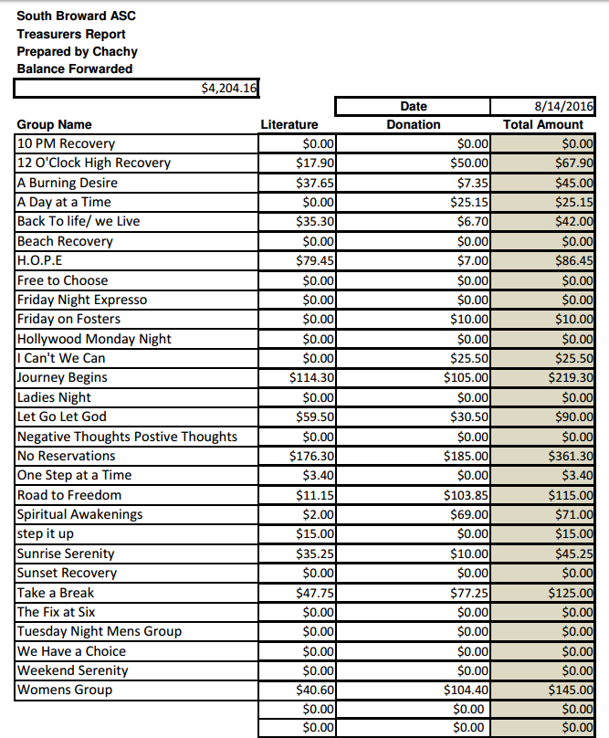
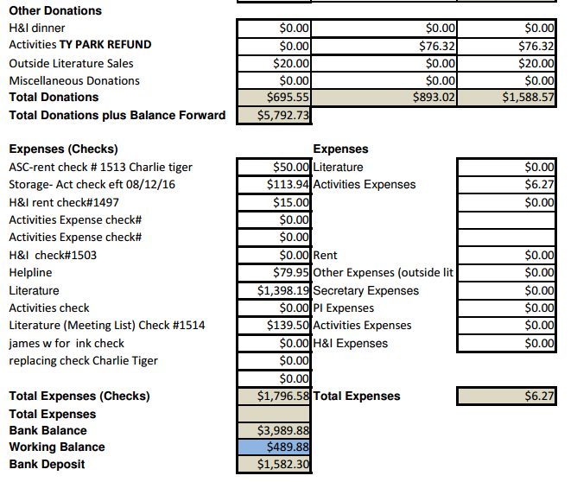

Policy Chair: – open position

Literature Chair: Morgan – Lit total 1322.72 which includes H&I’s order. We are getting a subcommittee together to help out. We have inventory on the computer now. If you did not get the order, I am sorry. If you have people in your home group or newcomers, let me know and we could use their help.

(AdHoc Chair) – Changing Time of Area: Max - I took the time to print up questionnaires and spent money out of my own pocket, yet not one was returned. I was thinking of running for Policy Chair but after this I am not sure.

GSR’S – GROUPS MUST VOTE ON NOMINATIONS & MOTIONS

NEW BUSINESS –
Journey Begins nominates Duke for H&I Chair
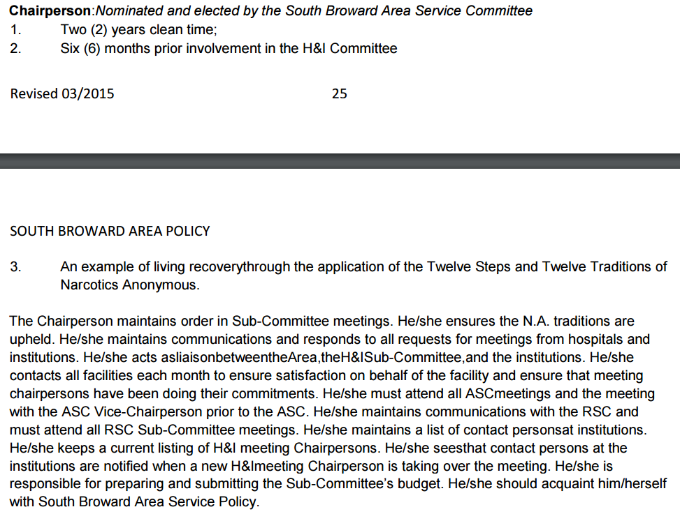

Qualifications:
I am currently the South Broward Area H&I Chair. I have 27 years clean. I only serve NA. I have an NA sponsor, NA home group. I have been doing service for the South Broward Area since 1993 and I am willing.

Robert S nominates Clint as Activities Chair
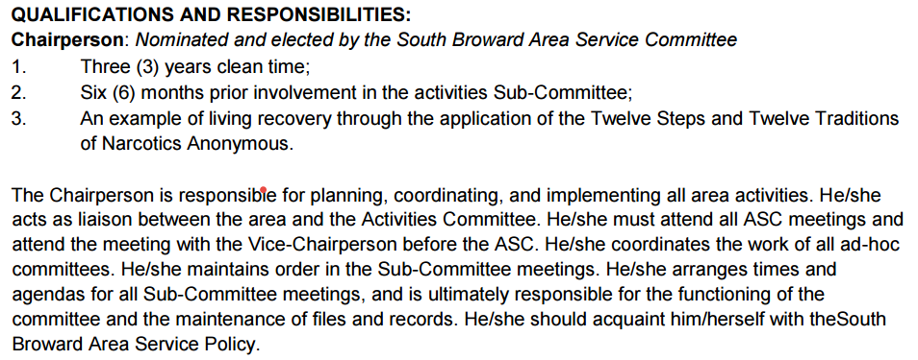

Requirements:
I have 7 years clean and have served on Activities for 6 years. I have a sponsor who has a sponsor.

OLD BUSINESS –
Area Nominations & Elections –

James S Vice-Chair acclimates to Area Chair - PASS
Liz S Alt RCM acclimates to RCM - PASS
Horacio Alt Treasurer acclimates to Treasurer - PASS

Mike nominate Robert S. as Vice-Chair - PASS

Area Motions – 12-4-1 - PASS
Motion 07-16-01 Maker: Max Second: Phil, Spiritual Awakening
Motion: To change the time that South Broward Area meets from 12pm to 10am. Area will still meet on the second Sunday of the month.

Intent: To allow more members to meet due to the inconvenience of the current mid-day time

Regional Motions - (WORLD MINS SENT AS SEPARATE EMAIL)
RSC Motions Tabled Back To Groups

Motion 06­01­16 Maker: Public Relations Second: South Broward
PASS
Motion Reads: To provide the Bahamas up to $30 per month for a period of one year paid directly to provider for a helpline number.

Intent: To aid a neighboring NA community that has been experiencing difficulty sustaining services. The Bahamas were previously a thriving member of the South Florida

Region & Instrumental in the creation of our Region.
Financial Impact: $360

Motion 06­02­16 Maker: ADMIN Second: Gold Coast
PASS
Motion Reads: To allow the time slot inventory AdHoc the liberty to try new scheduling ideas for the RSC weekend agenda during the next RSC cycle. This will be waiving the policy in regards to scheduling constraints.

Intent: This motion is directed to those who attend the RSC weekend to represent their area. (Subcommittee chairs and RCM’s)

It is to find a better schedule that allows for our growing region to be effective and accommodate the needs of all areas present at the SC weekend.
Regional Nominations & Elections
RSC Elections for Groups to Vote On:

Vice Chair:
PASS - Nomination for Mat S (Gold Coast RCM) made by RD. Nomination accepted.

PASS - Nomination of Robert (South Broward RCM) made by AD. Nomination accepted.

FAIL - Nomination of Jon B (Current MAL) made by RD. Nomination accepted.

Regional Delegate:
PASS - Nomination of Jeff P (Current Regional Delegate) made by AD. Nomination accepted.

Alternate Delegate:
PASS - Nomination for Kevin D (Current Alternate Delegate) made by Kevin D. Nomination accepted.

Treasurer:
PASS - Nomination for Toni P (Current Treasurer) made by Alternate Treasurer. Nomination accepted.

Alternate Treasurer:
PASS
Nomination for Barry S. (Current Alternate Treasurer) made by Gold Coast. Nomination accepted.

Alternate Secretary:
PASS
Nomination for Tara P (Central Florida) made by Secretary. Nomination accepted.

Hospitals & Institutions:
PASS
Nomination for Mason (Currently H & I Vice Chair) made by Vice Chair. Nomination accepted.

Newsletter:
PASS
Nomination for Natalia made by Peace River. Nomination accepted

Motion to Close: Robert
Seconded: All

