Next ASC is Sunday July 10, 2016
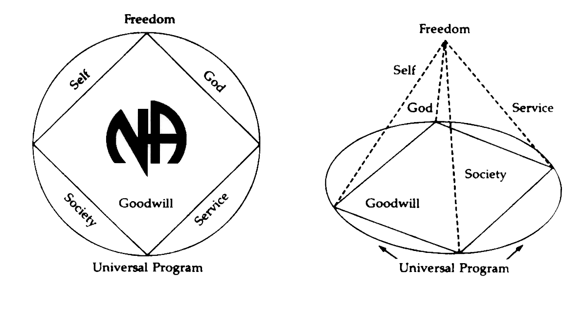
THERE WILL BE A
NEW GSR ORIENTATION BEGINNING AT 11:30am

PLEASE ANNOUNCE THE FOLLOWING AT YOUR MEETINGS:
WE NEED TRUSTED SERVANTS AT THE AREA LEVEL

ACTIVITIES TREASURER
NEWSLETTER CHAIR
POLICY CHAIR

Any questions or suggestions:
James W. (Chair): jrwashington954@gmail.com/954-274-1477
James S. (Vice Chair): Southersjames122014@gmail.com/754-204-5494
Barbara T. (Treasurer): tabaccob@comcast.net/954-448-1571
Sandy D. (Secretary): SBAreaSecretary@gmail.com/954-253-7578
Rachel B. (Alternate Secretary): Rayluvsty@2985@gmail.com/954-867-8911

South Broward Area ASC Minutes
James opened the meeting at 12:00 pm with the Serenity Prayer.
Dylan read the Twelve Traditions.
Evelyn read ASC Definition.

Open Forum- [All thoughts and opinions expressed in open forum are that of the individual and do NOT represent NA as a whole]

Frank - my group found a box if anyone wants to claim it

Kevin – I am the GSR again for Hollywood Monday Night

Chris - new GSR for We Have a Choice

Mike - new meeting called for veterans or for anyone. I need a starter kit.
Veterans in Recovery, Wednesday 7:00pm
4432 Pembroke Road, Hollywood, FL 33021

Dylan - Our meeting needs support and a starter kit
H.O.P.E. Friday 7:30pm
The Hope Stop Club House
218 E Dania Beach Blvd, Dania Beach

Steve – New Meeting
Always Hope meets Monday, Tuesday, Wednesday 7-8
The Hope Stop Club House
218 E Dania Beach Blvd, Dania Beach

Eric – Double Trouble Saturday
The Hope Stop Club House
218 E Dania Beach Blvd, Dania Beach

Roll Call
Admin Committee | MAY | JUN | JUL | Admin Committee | MAY | JUN | JUL
Chair: James W  954-274-1477  Jrwashington954@gmail.com | X | X |  | H&I Chair: Duke S  954-931-7083  dukehlwd@yahoo.com | O | X
Vice Chair: James S  754-204-5494  Southersjames122014@gmail.com | O | X |  | Literature Chair: Morgan F  321-207-6054  Frankrebel2011@hotmail.com | X | X
Secretary: Sandy D  954-253-7578  Sdeen1124@gmail.com | X | X |  | Policy Chair:  Open Position | X | O
Alternate Secretary: Rachel B  954-867-8911  Rayluvsty@2985@gmail.com | X | X |  | Activities Chair: Clint  954-614-2146  lynnbupps@gmail.com | X | X
Treasurer: Barbara T  954-448-1571  Tabaccob@comcast.net | O | X |  | Activities Treasurer:  Open Position | O | O
Alternate Treasurer: Horacio M  954-479-9447  Horacio.f.moreno@att.net | X | X |  | Helpline/PR Chair: Forest  forest@envisionwebdevelopment.com | X | O
RCM: Robert S  954-483-9147  Robertstuart5611@yahoo.com | X | X |  | Newsletter Chair:  Open Position | O | O
Alternate RCM: Liz S  754-208-7024  e.southers@outlook.com | X | X

# | Group | May | June | July
1 | 10 PM Recovery | X | X
2 | 12 O’Clock High Group | X | X
3 | Always Hope | O | X
4 | Back to Life We Live | X | O
5 | Beach Recovery | O | X
6 | Burning Desire | X | X
7 | Day at a Time | O | X
8 | Double Trouble | O | X
9 | Fix at Six | X | O
10 | Free to Choose | X | X
11 | Grey Book Group | X | O
12 | H.O.P.E. | O | X
13 | Hollywood Monday Night | X | X
14 | I Can’t We Can | O | O
15 | Journey Begins | X | X
16 | Ladies Night | O | O
17 | Let Go, Let God | X | X
18 | Negative Thoughts, Positive Reactions | O | X
19 | No Rezervations | X | X
20 | One Step at a Time | X | X
21 | Road to Freedom | X | X
22 | Spiritual Awakenings | O | X
23 | Step It Up | O | X
24 | Sunrise Serenity | X | X
25 | Take A Break | O | O
26 | Together We Grow | O | O
27 | We Have a Choice | O | X
28 | Women’s Group | O | X
Attendance Key: | X = Present | O = Absent
Three consecutive absences from one group will result in being deleted from roll call.
Quorum is Established at 15 (1/2 of 28+1)
Present 22 of 28 = Quorum Met

V. Trusted Servants Presentations by: Janice
VI. Acceptance of last month’s Minutes by: Betty, Mike
VII. Administrative Reports:

ASC Chair Report: James W. –
Everything is good.

ASC Vice-Chair -
As the new Vice Chair I have prepared myself for open positions: Activities Treasurer, Policy and any other things that I need to fulfill or help with in this Area. I am aware I will need to have Admin minutes directly following Area. We will be having one today just for a few minutes. This will include subcommittee chairs, GSRs, admin and anyone interested in attending. The next month will be spent on planning things that need to be done per policy: Admin meeting, yearly calendar, becoming a signature on bank account, stepping in as Activities Treasurer, continuing studying Policy and fulfilling my position to the best of my ability with the help of my fellow addicts.

Secretary: Sandy D –
Thank you everyone for being here. If there is ever anything that you need sent out before Area, please call, text or email me instead of waiting until Area to bring it to my attention.

RCM: Robert S. –
This month we sent out some things to vote on we will be taking those votes back with us to region next weekend at the Deauville in Miami. The secretary forgot to send out the accessibility questionnaire in last month's minutes so we will not have those for the committee chair person. This is a little disappointing because she worked very hard on those and needs feedback.
ILS, Robert S
Alternate RCM: Liz S. – no report.

Activities Chair: Clint –
We need a check for St. James for $250 so we can have that space for Thanksgiving. We reserved a spot in West Lake for a Summer Bash but spot was too small, so we are getting that money back. We checked TY Park but everything is booked up until August. We are planning on having Summer Bash on Aug 21 but we need a check before we can reserve. It’s a Sunday and the same weekend as Regional in Punta Gorda.

Helpline/PR Report: Forest – not present.

H&I Chair: Duke –
First off I’d like to thank everyone that participated in last night’s H&I; I gratitude dinner. It was very successful. Many attended and we ran out of food so that means very little waste. Unfortunately some people were left hungry. We haven’t calculated the finances yet however; I will be requesting a deposit slip from our treasurer so I can make a deposit when we are complete. We are looking to deposit about $1000. We haven’t had a major problem with our literature in the past but we have had some. Our hope is the money we deposit will help pay for H&I; I literature and that our orders will be complete. It’s also our responsibility to make sure we are here to pick it up each month.

We lost a couple members over the past month who decided to move on and we will lose another one this month. We have spots open. Please join us. We added a new facility this past month. It is a detox called Ocean Breeze. It is a Wednesday night meeting. We currently have 6 facilities with only one chair that is covering every week. We need volunteers.

There will be a Florida State Prison clearance on June 20 at the Hollywood Work Release Center 8501 N. Cypress Dr. Pembroke Pines, FL 33025. At is located behind the VA facility on the South Florida State hospital grounds. For more information please see me.

We currently have 31 presentations in 10 facilities with 7 open meetings.

ILS, Duke

2016 H&I Gratitude Dinner

Cost Breakdown Donations

$ 140.00 Tickets and Magnets $ 1,112.00 Pre Ticket sales

$ 20.00 Flyers $ 420.00 Door and Donations

$ 225.00 Rent $ 184.00 T Shirt auction

$ 185.00 Restaurant Depot $ 1,716.00 Total received

$ 101.00 Table and Chair rental

$ 15.00 Together We Grow

$ 10.00 Free to Choose

$ 20.00 Ice

$ 716.00 Total Cost

Total Donated to South Broward Area $ 1000.00

Donated June 15, 2016

Alternate Treasurer: Horacio M – (See next page)
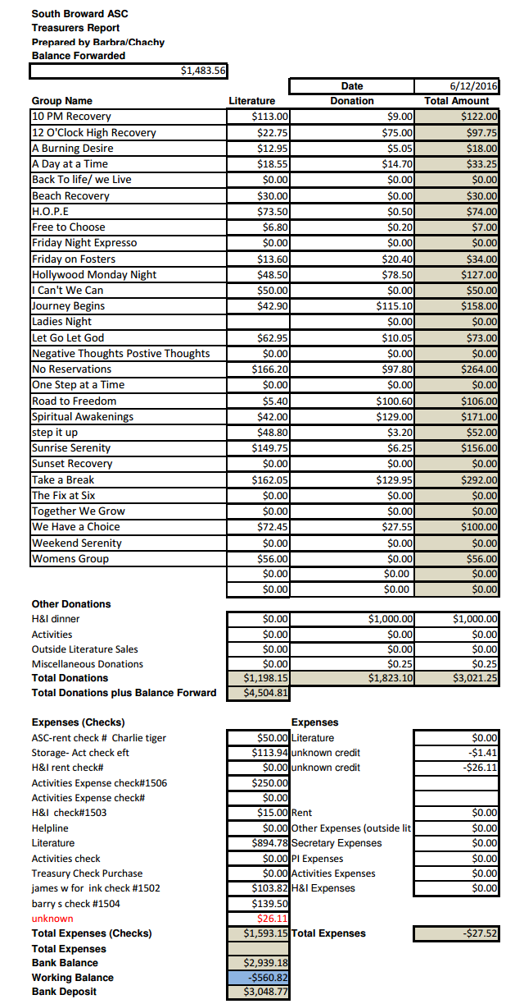
Policy Chair: James S –
I have been reading Policy over because I will need to now because I am moving to Vice Chair. I will help with Policy until we have someone new. Thank you for letting me serve.

Literature Chair: Morgan –
Budget of 900.00, we made 894.78 total. Just me today so it is going to be slow. We have 3 starter packs and I will try to get it all together for you guys.

GSR’S – GROUPS MUST VOTE ON HIGHLIGHTED MOTIONS

NEW BUSINESS –
Nominations & Elections – none

Area Motions
PASS
Motion 06-16-01 Maker: RCM Second: Journey Begins
Motion Reads: To Skip Summer Activity this year and schedule July 4th Activity in 2017.
Intent: Since it is too late to secure a facility, it is too late in the year to attempt this. Scheduling it next year will give us plenty of time to plan the event.

Regional Motions - none

OLD BUSINESS –
Nominations & Elections –
James S elected as Area Vice-Chair
Rachel B elected as Alternate Secretary

Area Motions –
FAILS
Motion 05-18-16 Maker: Greybook Second: Back to Life We Live
Motion Reads: To change Policy in 9C from “The Chairperson has a vote only in the case of a tie” to instead read as “The Chairperson has a vote only in the case of a tie except in matters of group conscience.”

Regional Motions –
FAILS
Motion 04-03-16 Maker: ADMIN Second: S. Dade
Motion Reads: This is a question for the groups of the South Florida Region; Do you want a regional convention in 2018?? Yes or No

Motion to Close: Let Go Let God
Seconded: One Step at a Time

