Next ASC is Sunday March 13, 2016
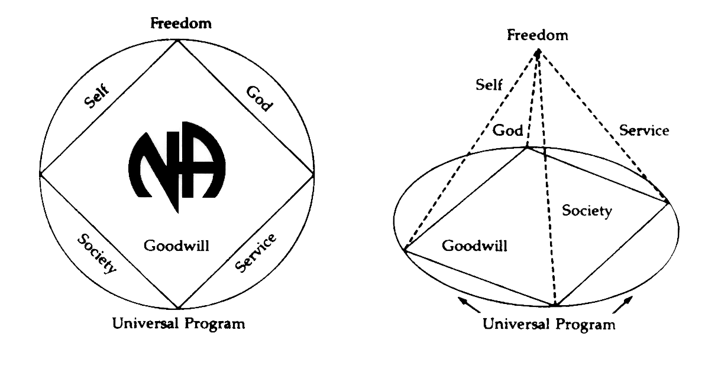
THERE WILL BE A
NEW GSR ORIENTATION BEGINNING AT 11:30am

PLEASE ANNOUNCE THE FOLLOWING AT YOUR MEETINGS:
WE NEED TRUSTED SERVANTS AT THE AREA LEVEL

VICE CHAIR
SECRETARY
ALT SECRETARY
ACTIVITIES TREASURER
HELPLINE/PR CHAIR
NEWSLETTER CHAIR

Any questions or suggestions:
James W. (Chair): jrwashington954@gmail.com/954-274-1477
Barbara T. (Treasurer): tabaccob@comcast.net/954-448-1571
Sandy D. (Acting Secretary): sdeen1124@gmail.com/954-253-7578

South Broward Area ASC Minutes
James opened the meeting at 12:00 pm with the Serenity Prayer. Taylor read the Twelve Traditions. David read ASC Definition.

Open Forum- [All thoughts and opinions expressed in open forum are that of the individual and do NOT represent NA as a whole]

Robert – motion to change the order of business to do nominations and elections first. Passes.

David – commend Robert for assisting his home group with motions and CAR report!

James – Thank you Robert for all the groups you went to help!

Ken – there is a lot of resistance with motions and CAR because people feel like what we say at area does not matter.

Barry – Thank all the people who helped with PR table yesterday!

Evelyn – I am with Negative Thoughts Positive Reactions. I wanted to reintroduce myself. Our GSR is YoFrank and we have 11 alternates. You will see rotating people from our group.

Wayne – GSR from a new group named H.O.P.E. Requesting starter pack.
H.O.P.E. meets Fridays at 7:30 – 8:30pm. It is in English, S/TD, wheelchair accessible and an open meeting. Located: Frost Park, 300 NE 2nd Street, Dania Beach, FL 33004

Taylor – New alternate GSR for Ladies Night

David – New alternate GSR for new meeting Fix at Six

Frank – New alternate GSR for Spiritual Awakenings

Crystal – New GSR for Take a Break

James – Secretary and Vice Chair stepped down. Introduced Sandy as Acting Secretary and Rachel as Acting Alt Secretary. Read Bruce’s report where he submitted his resignation.

Roll Call

Admin Committee | JAN | FEB | MAR | Admin Committee | JAN | FEB | MAR
Chair: James W  954-274-1477  Jrwashington954@gmail.com | X | X |  | H&I Chair: Duke S  954-931-7083  dukehlwd@yahoo.com | X | X
Vice Chair:  Open Position | X | O |  | Literature Chair: Morgan F  321-207-6054  Frankrebel2011@hotmail.com | X | X
(Acting) Secretary: Sandy D  954-253-7578  Sdeen1124@gmail.com  Open Position | O | X |  | Policy Chair: James S  754-204-5494  Southersjames122014@gmail.com | X | X
(Acting) Alt Secretary: Rachel  954-867-8911  Rayluvsty@2985@gmail.com  Open Position | O | X |  | Activities Chair: Clint  954-614-2146  lynnbupps@gmail.com | X | X
Treasurer: Barbara T  Tabaccob@comcast.net | X | X |  | Activities Treasurer:  Open Position | O | O
Alternate Treasurer: Horacio M  954-479-9447  Horacio.f.moreno@att.net | O | X |  | Helpline/PR Chair:  Open Position | O | O
RCM: Robert S  954-483-9147  Robertstuart5611@yahoo.com | X | X |  | Newsletter Chair:  Open Position | O | O
Alternate RCM: Liz S  754-208-7024  e.southers@outlook.com | X | X

GROUP | JAN | FEB | MAR
1. A Day at a Time | O | O
2. Back to Life We Live | X | X
3. Beach Recovery | O | O
4. Bitter Ends Group | X | O
5. Conscious Contact | X | X
6. Fix at Six | O | X
7. Free to Choose | X | O
8. Friday Night Espresso | X | O
9. Friday on Foster | O | O
10. Grey Book Group | X | X
11. Hollywood Monday Night | X | X
12. H.O.P.E. | O | X
13. I Can’t We Can | X | X
14. Journey Begins | X | X
15. Ladies Night | X | X
16. Let Go, Let God | X | X
17. No Rezervations | X | X
18. Negative Thoughts, Positive Reactions | X | X
19. One Step at a Time | X | X
20. Road to Freedom | X | X
21. Spiritual Awakenings | X | X
22. Step It Up | X | O
23. Sunrise Serenity | X | X
24. Take A Break | O | X
25. The Women’s Group | X | X
26. Together We Grow | X | X
27. We Have a Choice | X | X
28. 10 PM Recovery | X | X
29. 12 O’Clock High Group | X | X

Attendance Key: | X = Present | O = Absent
Three consecutive absences from one group will result in being deleted from roll call.
Quorum is Established at 15 (1/2 of 28+1)
Present 22 of 30 = Quorum Met

IV. Reading of the second to the last paragraph of Prefix (page xvi) of Basic Text completed by: Ken
V. Trusted Servants Presentations by: Evelyn
VI. Acceptance of last month’s Minutes by: Mike
VII. Administrative Reports:

ASC Chair Report: James W. – We have no Vice Chair, no Secretary or Alternate Secretary. Robert made a motion, which passed, to change the order of business to nominations and elections, so we will start there today.

ASC Vice Chair Report : Bruce – LETTER OF VICE CHAIR RESIGNATION
In my January report I stated that because of my work schedule I will not be able to attend both the Activities and Public Relations subcommittee meetings. After the ASC meeting on January 10, 2016 the Area Chair stated that I was not fulfilling my responsibilities as Vice Chair of Area. It is for that reason that I must submit my resignation as the Vice Chairperson of the South Broward Area.

Secretary’s Report: Brittany P. - To Members of South Broward Area Service Committee,
I am writing this to formally inform everyone of my stepping down as Secretary of South Broward Area. I want to apologize for my absence at area for the last two months. I didn’t notify anyone that I would not be there and that is not acceptable. I intended on being at Area to do this in person but it was not possible for me to be there. I am learning today to handle my affairs with integrity. I took on employment that is very demanding of my time. I initially applied for a position and it has become a much bigger position with greater responsibility.

I understand the importance of the commitment of secretary of area. I learned a lot about the business side of Narcotics Anonymous. Unfortunately, I have to let go of my secretary position. My job does not allow me to fulfill the commitment to the best of my ability. I am truly grateful for this opportunity and the faith that you all had in me to do this position, as well as the support everyone gave me. Hopefully, I will be able to take on another commitment like this at a later time and be able to give back to NA.

Thank you all for your love and support.

RCM Report: Robert S. - I am looking forward to region on the West Coast next week. Please hand in word lit survey forms today if at all possible. Please have CAR report motion form to hand in by next area. Thank you.

Alternate RCM Report: Liz S. – No Report.

Activities Chair: Clint - We are doing well but need a lot of support at meetings and events. You will receive four flyers, two to be posted and two to put in your books. Please have your secretaries read them. We have scheduled our Area Anniversary Event on Sunday, April 17 at TY Park. We are requesting a check for 54.05 for paper and ink, 200.00 TY Park deposit and 200.00 for Luther Memorial Church for Christmas and New Year’s. We need an Activities Treasurer because I am doing both roles right now. We are thinking of moving our warehouse closer which will cost us 109.00 per month and five keys allowed to it. March 10 – Open House Activities meeting. Flyer in there for that. Thank you for letting me be of service.

H&I Chair: Duke – We had 7 new members, 17 members in attendance. However, we still have a bunch of open positions. We filled 2 open spots and started a new day because people stepped up. 3 of the new members will come back and accept positions at another time. Recovery First residential is trying to get us to add another day, even though we currently have 4 days with them. They love us and I have great communication with the contact person there. We do have an AdHoc Chair, Linda so we are going to start moving forward with our H&I Gratitude dinner which should take place in June. Policy still calls for an H&I gratitude dinner every 2 years. Let me know if anyone wants to get involved with that. We elected Vice Chair Ryan W. Still looking for a Secretary and Orientation Chair. At our last Regional meeting, one thing we talked about was PenPal, JailMail. They asked for us to ask our committee what we thought. 5 of 9 voting members thought it was a good idea to explore further. They are still ironing some things out like addresses and safety.

Putting in check requests for $15 for rent, $30.54 for 2 months of copies for making minutes and reports for the committee.

GSRS ANNOUNCE H&I OPENINGS AT YOUR MEETINGS

2 openings for Broward Girls’ Academy – No Clearance through BSO Required – Near Susan B off Pembroke Road

Opening for Hollywood Work Release – 1 day a month – Female with State Clearance

Openings for Star Program – South Florida State Hospital – Tues and Fri Nights

Openings at Broward County Jail – Men’s Side

Alternate Treasurer’s Report: Horacio M – I had to make an adjustment on the report that I gave at the ASC. I entered $18.00 instead of $118.00 for one of the groups. I found this when I was counting the money. Also, we were $6.00 short.

(See report, next page)
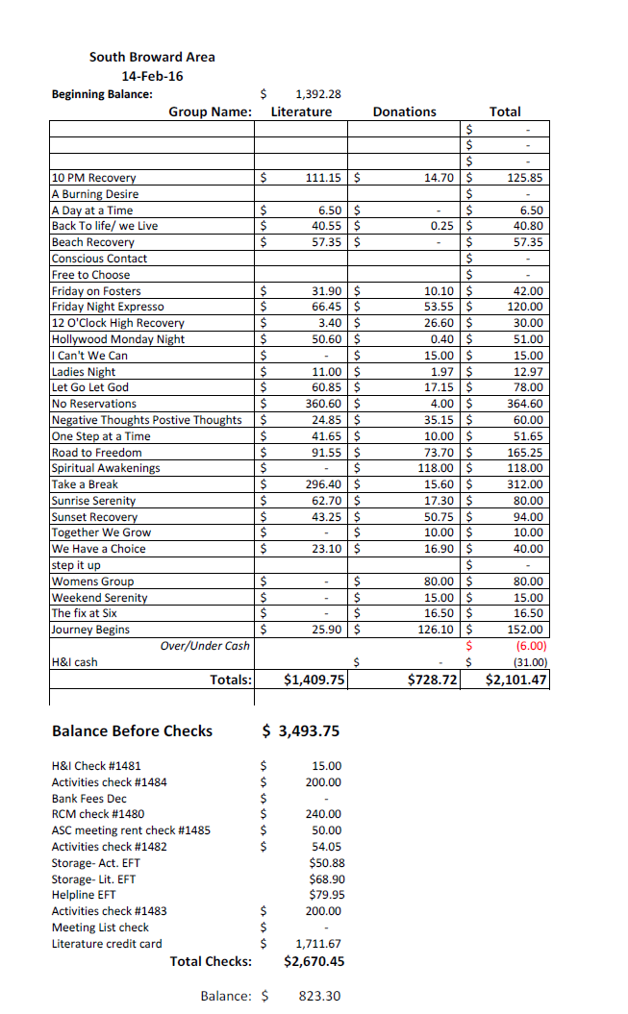

Policy Chair: James S – Everything is good. I shared with a couple individuals this morning about what is going on in Policy. Today some votes are coming back with some changes in Policy. If it passes, those changes will be made and updated on the website. I’ll check Policy on how many times a year we have to print it.

GSR’S – GROUPS MUST VOTE ON MOTION & NOMINATION

NEW BUSINESS –

Motion

#02-16-01 from Activities Seconded by Take a Break
To move the storage warehouse closer to area location.
Intent: More convenient for area and cheaper.

Nomination

Robert nominates Sandy for Area Secretary.

Requirements:
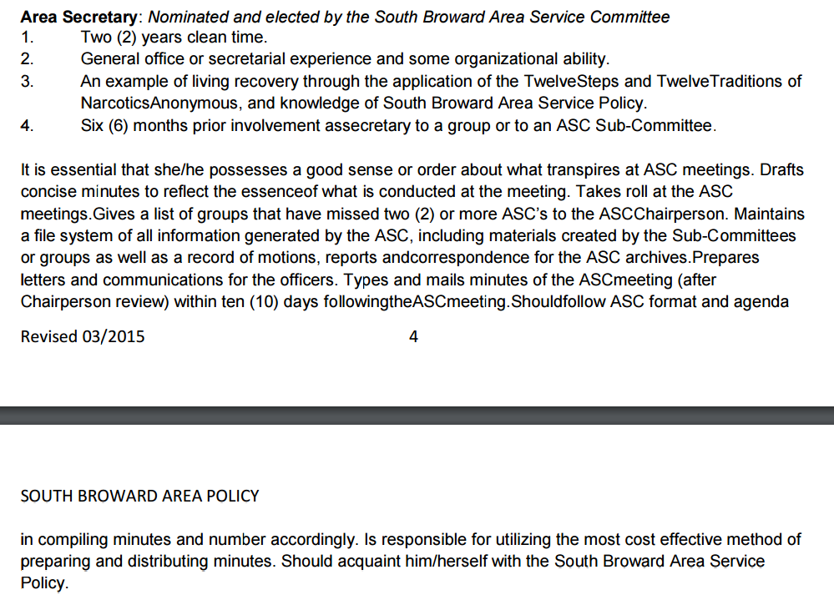

Qualifications:
Sandy – I have over 4 years clean. I was previously Alternate Secretary and Secretary of the South Broward Area. Upon acceptance into graduate school, I had to resign as Secretary to fulfill work and school obligations, yet continued to help the secretary when asked. I have since graduated with a Masters Degree in Business. I have the willingness and fulfill all of the requirements needed for the position.

OLD BUSINESS -

Regional Motion

To accept or oppose the Southeastern Zonal Forum Guidelines.
ABSTAIN

On behalf of Journey Begins, Barry requests Robert to bring two amendments to the guidelines back to region. [Treasurer should not be co-signer with Secretary on checking account]
[Budget – Per Diem amount for travelling should show a dollar amount]

Area Motions

#01-16-01
To Change Policy pages 13, 14 to say: All sub-committee chairs that are required to attend the RSC will be reimbursed up to $200.00 upon presentation of receipts of expense for travel and lodging outside Dade, Broward and Mid Coast Areas and up to $300.00 if required to stay 2 nights.
DOES NOT PASS

#01-16-02
To Change Policy pages 13, 14 to say: The RCM and/or Alternate will be reimbursed up to $200.00 each at the ASC prior to the RSC for travel and lodging outside Dade, Broward and Mid Coast Areas and up to $300.00 if the RCM or Alternate is required to stay 2 nights. Receipts will be turned in at the next ASC.
DOES NOT PASS

#01-16-03
To Change Policy pages 13, 14 to say: The RCM and Alternate RCM will not be reimbursed for travel together. If the alternate goes to the RSC for learning purposes he/she will go to an RSC within Dade, Broward or Mid Coast Areas. Should there not be any RSC’s in the Dade, Broward or Mid Coast areas prior to the alternate becoming the RCM then both the RCM and Alternate could travel together and both get reimbursed one time.
DOES NOT PASS

#01-16-04
To establish an email for South Broward Area NA secretary. Accessible by Admin Committee.
PASS

#01-16-05
To change our Helpline from what we have to the regional phone line. It will cost us $0 a month.
PASS

Motion to Close: James W
Seconded: Robert S

