Date: October 08, 2017 Next ASC: Sunday November 05, 2017 at 10:00 AM

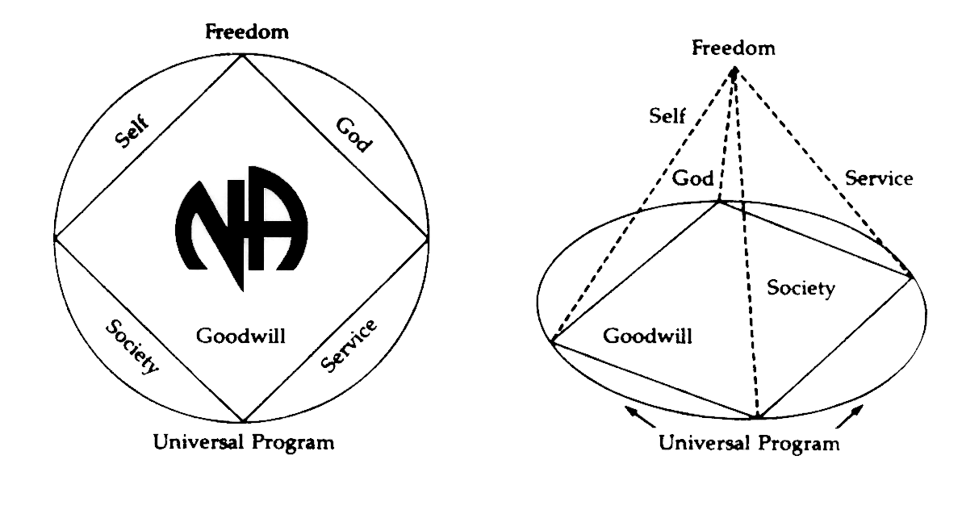

GSRS
PLEASE ANNOUNCE THE FOLLOWING OPEN POSITIONS AT YOUR MEETINGS. WE CURRENTLY HAVE NO NOMINATIONS FOR THE FOLLOWING POSOTIONS AND AREA IS IN NEED OF SERVICE:

ACTIVITIES TREASURER
ACTIVITIES CHAIR
ALTERNATE SECRETARY

Please contact Admin Committee members if you have any questions or suggestions. All Admin positions are up for new elections except for Secretary at our next ASC business meeting. All contact will be updated in the September minutes:

YO Frank (Chair): Yofrank@bellsouth.net 954-963-7265
(Vice Chair): Open Position/Nomination in Place
Horacio M. (Treasurer): Horacio.f.moreno@att.net 954-479-9447
Ashley C. (Secretary): SBAreaSecretary@gmail.com 954-551-5687
Robert S. (RCM): RobertStuart5611@yahoo.com 954-483-9147

- Opening 10 AM
- Yo Frank read Serenity Prayer
- Kevin read 12 Traditions
- Robert read Definition of an ASC
- Yo Frank called for check requests and/or motions called to be turned in.

Robert S. reported he sent in check request for the South Broward Thanksgiving Day event for $200. The $200 pays for rent.
NO MOTIONS SUBMITTED

- Open Forum
[All thoughts and opinions expressed in open forum are that of the individual and do NOT represent NA as a whole]

- Introduce New GSRs

Jerry C.: New GSR for Back to Life We Live Group johnboatjerry@gmail.com

Michael: New GSR for Sunrise Serenity Group (member has yet to submit his contact information)

Kevin: New GSR for 10PM Recovery Group kevinfisher785@gmail.com

Orlando: New GSR for We Have a Choice Orlando.774@hotmail.com

OPEN FORUM IS FOR ANYONE WHO NEEDS TO MAKE AN ANNOUNCEMENT OR BRING SOMETHING TO AREA’S ATTENTION. THIS IS NOT FOR DISCUSSION. TWO QUESTION LIMIT PER PERSON.

Prescott: My Home Group, We have a choice, has a new location at the new West Broward Club. Thursdays at 8:30pm. 5625 S. University Drive, Davie FL 33328. Please Park behind the Barbershop. Come out and support us.

Bruce: I am the new chair for the SFRCNA host committee. The convention is in 2019. WE don’t know where it will be held but we know it will be held somewhere in the North Zone. I’m disappointed to say that no one from this area showed up to the host elections committee yesterday. I would definitely hope to see members from our area come out to the next one.
Joanne: will this be posted on the regional website?
Bruce: yes

B. Zoom Zoom collections were not collected.

3. Roll Call: Present = P Absent = A Open = O
A. Administrative Committee- Please notice positions up for nominations and elections
B. Subcommittees - Please notice positions up for nominations and elections
C. Groups

ADMIN COMMITTEE | Aug | Sep | Oct | ADMIN COMMITTEE | Aug | Sep | Oct
Chair:  Yo Frank |  |  |  | H&I Chair:  Ryan W.
954-963-7265 | - | P | P | 267-980-4623 | P | A | A
Yofrank@bellsouth.net |  |  |  | Ry85AN@yahoo.com
Vice Chair:  Open Position/Nomination in place | O | O | O | Literature Chair:  Linda S  954-295-8473  linnie91557@yahoo.com | - | P | P
Secretary:  Ashley Q | P | A | P | Policy Chair:  Max S. | P | P | P
954-551-5687 |  |  |  | 954-549-8728
SBAreaSecretary@gmail.com |  |  |  | maxlj334@gmail.com
Alternate Secretary: | O | O | O | Activities Chair: | O | O | O
Open Position |  |  |  | Open Position
Treasurer:  Horacio M |  |  |  | Activities Treasurer:
954-479-9447 | P | P | P | Open Position | O | O | O
Horacio.f.moreno@att.net
Alternate Treasurer:  Barry |  |  |  | Helpline/PR Chair:  Steve  954-588-0785
954-298-5971 | P | P | P | stevewr57@outlook.com | P | P | A
na51998@aol.com
RCM:  Robert S. | - | P | P | Alternate RCM: | O | P | P
954-483-9147 |  |  |  | Joanne G  754-423-5035  realtorjoanngamble@gmail.com
RobertStuart5611@yahoo.com

Three consecutive absences from one group will result in being deleted from roll call. The Following groups were removed due to lack of attendance.
H.O.P.E ralphmacia56@gmail.com
24 Hour Solutions maxinehaynes32@gmail.com
One Step At a Time nicoleannmetro@gmail.com
The Following groups were added due to being a new group or back in attendance with Area.
We have a choice Hawaiiguy73@gmail.com

Quorum is Established at (1/2 of 26+1)=19.
Present 18 of 26 = Quorum Met

# | Group | Aug | Sept | Oct
1 | 10 PM Recovery kevinfisher785@gmail.com | PP | P | P
2 | 12 O’clock High Group dgree714@bellsouth.net | PP | P | P
3 | We have a choice Orlando.774@hotmail.com | AA | P | P
4 | A Day at a Time SJGamble@comcast.net | PP | A | P
5 | Conscious Contact Pkelner.realestate@gmail.com | PP | P | P
6 | Back to Life We Live johnboatjerry@gmail.com | PA | A | P
7 | Bitter Ends 7542451339ly@gmail.com | PP | A | P
8 | Sunrise Serenity jrwashington954@gmail.com | PP | P | P
9 | A Burning Desire eric@dbamericas.com santiago44jsj@aol.com | PP | P | P
10 | The Feminine Principles kir.schneider@yahoo.com | PP | A | A
11 | Free to Choose Bettymunro1@gmail.com | AA | A | P
12 | Fridays on Foster frankt@dockproducts.com | PP | P | P
13 | Hollywood Monday Night kcar747@icloud.com | PP | A | P
14 | Tuesday Night Steps Mccottrie@yahoo.com | PP | A | A
15 | I Can’t We Can Jaswaltermi@aol.com | PP | A | P
16 | The Journey Begins norma-94@comcast.net | AA | P | A
17 | Let Go, Let God amsmacho1545@gmail.com | AA | P | P
18 | Negative Thoughts, Positive Reactions | PP | P | A
19 | No Rezervations adwest118@gmail.com | AA | P | P
20 | Women’s Group jbillie99@bellsouth.net | PP | A | A
21 | Road to Freedom pamhott@mac.com goraiders.kt@gmail.com | PA | A | A
22 | Spiritual Awakenings philkas@comcast.net | PA | A | P
23 | Step It Up maxlj334@gmail.com | PP | P | P
24 | Sunset Recovery myflagandbanner@aol.com | PP | P | P
25 | Take a Break austin11b@yahoo.com | PP | A | P
26 | Veterans in Recovery Mkeels@broward.org | PP | A | A

4. Bruce read the second to last paragraph of Prefix (Page XXVI) of Basic Text
5. Bruce gave a Trusted Servants Presentation: (Admin Member, Committee Chair, or GSR) will share a short presentation of their service position including their role within the body they serve, the responsibility of their position, and any other pertinent information that may be helpful to those members new to the service structure. (Policy P. 2 lines 41-44)

6. Acceptance/Corrections of last month’s Minutes: Accepted by RCM Robert S and second Sunset Recovery.

Format

7. Administrative Reports:

- ASC Chair Report: YO Frank

No Report Submitted. Yo Frank was elected today.

- ASC Vice-Chair: NO REPRESENTATIVE OPEN POSITION

- Secretary: Ashley Q

Hi Everyone, Please submit your contact information to me if you are a new GSR or representing a new group. Admin and Sub Committee members please don’t forget to email me or submit a written report to myself for the minutes.

- RCM: Robert S

Robert S was elected today.
As pro-tempt RCM I got the chair’s book from previous chair and gave it to Yo Frank
Current chair. I also put in a check request for our Thanksgiving Day event for $200 as rent. In loving service Robert S

E. Alternate RCM: Joanne G.
No Report Submitted. Joanne G. was elected today.

8. Subcommittee Reports

A. Activities Chair: NO REPRESENTATIVE OPEN POSITION

B. Activities Treasurer NO REPRESENTATIVE OPEN POSITION
C. Helpline/PR Chair: Steve R Not Present but submitted report to secretary
WAS NOT SHARED DURING AREA. PLEASE READ, REVIEW, AND HAVE YOUR GROUPS VOTE

Greetings from your Helpline/Public Relations Subcommittee. Due to the storm, we have not met since our last area. Our 2017-2018 budget proposal will be included in the October minutes. Please review and have members of your groups vote. On September 29 PR was asked to attend Patient Recovery Day at the Broward Treatment Center in Hollywood. Literature was available to all clients as well as answers to any questions regarding Narcotics Anonymous. We are always in need of support. We meet the third Thursday of every month at 7:15 at Luther Memorial Church 1925 N. State Road 7 Hollywood, FL 330023. Steven
Line Item | 2016-2017 Approved | 2016-2017 Actuals | 2017-2018 Proposed | Increase/decrease | Justification
One Box | 960 | 958.60 | 960
Website | 750 | 125 | 750
Booth  Maintenance | 500 | 228.30 | 500
Operating  Expenses | 150 | 68.01 | 150
Special  Projects | 500 | 0 | 500
RSC Travel | 380 | 72.42 | 380
Rent | 120 | 180 | 240 | +120 | New Meeting Location
Totals | 3360 | 1532.33 | 3480 | +120 | New Meeting Location

- H&I Chair: Ryan W. Not Present
No report submitted.

- Literature Chair: Linda S
Please see attached Invoice. Linda S was elected today.
SOUTH BROWARD LITERATURE REPORT
OCTOBER 8, 2017
H&I REQUESTED 225.00
AREA LIT ORDER 92.38
MEETING LIST 111.30

TOTAL THIS MONTH 428.68

Linda S requested a laptop for budgeting and Inventory. Laptop was approved. The sub committee would also like to start storing inventory where we hold area service. The motion was tabled to address during next month’s area meeting due to needed to find out if this was a possibility first.

- Policy: Max S.
No report submitted.

- Adhoc Committees: N/A
- Convention Committee: N/A
- Treasures Report- Horacio and Barry

Horacio and Barry were re-elected today. See attached report.

GSR’S – GROUPS MUST VOTE ON NOMINATIONS & MOTIONS

Please Reflect to POLICY on the website to view qualifications for open positions and nominations until each group is provided their own by the Policy Chair. Thank You

9. Nominations & Elections

- South Broward Area Nominations & Elections

- Liz S withdrew her Chair Nomination via email last month

- Kevin S withdrew his Activities Chair nomination last month

- Bruce withdrew his Nomination for RCM last month

- James W withdrew his Nomination for Vice Chair

VOTE

- Vice Chair Nomination
Armand nominated Prescott for Vice Chair of Area
Max: Read all responsibilities and qualifications for Vice Chair of area.
Prescott: My name is Prescott I'm an addict, regarding my nomination as Vice chair for South Broward area service committee my qualifications are as follows, my clean date is June 5 in the year 2000 I have worked the 12 steps and I do my best to live by those principles on a daily basis. I have an NA sponsor who has an NA sponsor who has an NA sponsor. I am aware of the requirements for the position and I have a willingness to serve as vice chair if elected. My home group is we have a choice, Thursday nights at 8:30 at West Broward Club. I have served as a GSR, secretary, treasurer, and also served in this area as alternate secretary and Secretary at area level. I have been involved with the South Broward area for 10 years and previously served as alternate chair and chairperson in the Honolulu area in 2005

PLEASE BRING ALL NOIMATIONS BACK TO YOUR GROUP AND VOTE ON HELPLINE BUDGET

- Literature Chair Election

NO OPPOSITION. UNAMIMOUSE VOTE. LINDA S. WAS VOTED IN FOR LIT CHAIR

- Treasurer Election

NO OPPOSITION. UNAMIMOUSE VOTE CHACHY WAS VOTED IN FOR TREASURER

- Alt Treasurer Election

NO OPPOSITION. UNAMIMOUSE VOTE BARRY WAS VOTED IN FOR ALT TREASURER

- RCM Election

NO OPPOSITION. UNAMIMOUSE VOTE ROBERT S. WAS VOTED IN FOR RCM

- Alt RCM Election

NO OPPOSITION. UNAMIMOUSE VOTE JOANNE G. WAS VOTED IN FOR ALT RCM

- Area Chair Election

NO OPPOSITION. UNAMIMOUSE VOTE YO FRANK WAS VOTED IN FOR AREA CHAIR.

- Regional Nominations & Elections

NONE REPORTED

10. Old Business:

A. South Broward Area Old Business:
NONE

- Regional Old Business:

NONE REPORTED

11. New Business:

- South Broward Area New Business

NONE REPORTED

- Regional New Business

NONE REPORTED

12. Announcements- Ask for volunteers to help clean up.
13. Motion to Close with Serenity Prayer: Let Go Let God Seconded: All

