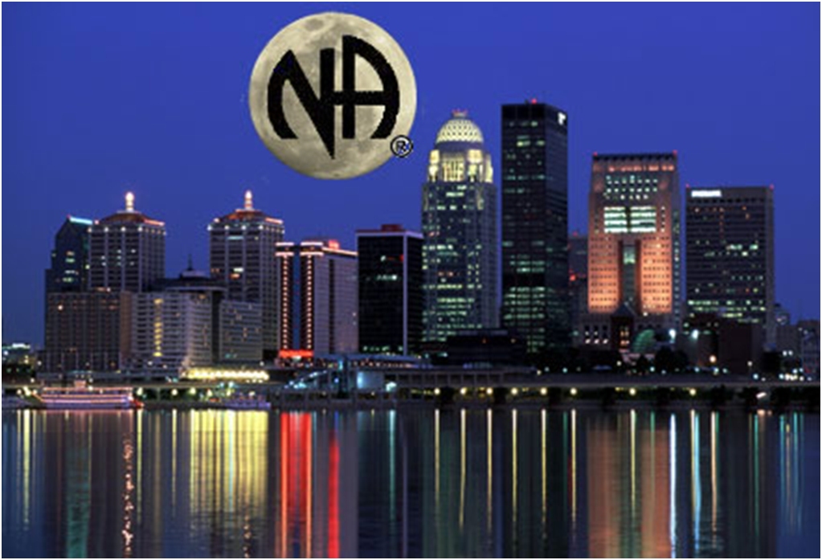

NORTH DADE AREA CONVENTION OF NARCOTICS ANONYMOUS

DATE____________

FIRST NAME___________________________ LAST NAME___________________________

ADDRESS______________________________________________________APT #_________

CITY____________________________STATE_________________________ZIP___________

PHONE________________________________EMAIL_________________________________

AREA_________________________________ CLEAN DATE__________________________

**$25.00 for Registrations received before: March 31, 2016**

**$35.00 for Registrations received after: 03/31/2016**

**Convention Dates: August 5-7, 2016**

|  |  |
| --- | --- |
| **CONVENTION REGISTRATION INFORMATION** | **HOTEL RESERVATION INFORMATION** |
| *To mail in your Registration, make check or money order payable to:*  **North Dade Area Convention of**  **Narcotics Anonymous**  *P.O. Box 420217 Miami, FL 33242*  *For more information, contact:*  Synthia M. (786) 436-6671 Deborah W. (786) 344-3090 or Yvette W. (786)266-6487 | *To make Hotel Reservations call:*  **Deauville Beach Resort**  *6701 Collins Avenue Miami, Florida 33141*  *(305) 865-8511* ***Use code: NDACNA***    *City View $119*  *Ocean View $139*  *Ocean Front $169*  *Jr. Suite $189* |

**Convention Activities – TBA (TO BE ANNOUNCED) in March 2016**

**WHY REGISTER EARLY…?**

Pre-registration funds are used to pay for hotel and convention facilities, equipment, services, supplies, maintenance, insurance, registration packets, and other convention related expenses. Your registration fees and participation help us make this event possible.