Next ASC is Sunday June 12, 2016
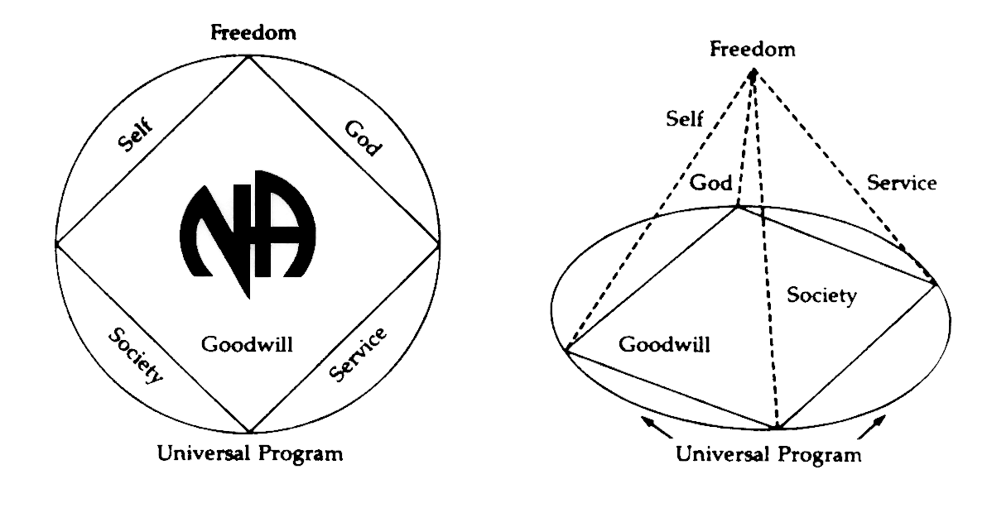
THERE WILL BE A
NEW GSR ORIENTATION BEGINNING AT 11:30am

PLEASE ANNOUNCE THE FOLLOWING AT YOUR MEETINGS:
WE NEED TRUSTED SERVANTS AT THE AREA LEVEL

VICE CHAIR
ALT SECRETARY
ACTIVITIES TREASURER
NEWSLETTER CHAIR

Any questions or suggestions:
James W. (Chair): jrwashington954@gmail.com/954-274-1477
Barbara T. (Treasurer): tabaccob@comcast.net/954-448-1571
Sandy D. (Secretary): sbareasecretary@gmail.com/954-253-7578

South Broward Area ASC Minutes
James opened the meeting at 12:00 pm with the Serenity Prayer.
Ken read the Twelve Traditions.
Mike read ASC Definition.

Open Forum- [All thoughts and opinions expressed in open forum are that of the individual and do NOT represent NA as a whole]

David – Fix at Six is now meeting at 6:30pm. Location is the same at Broward College, Davie, Building 9 and Room 110

Roll Call
Admin Committee | APR | MAY | JUN | Admin Committee | APR | MAY | JUN
Chair: James W  954-274-1477  Jrwashington954@gmail.com | X | X |  | H&I Chair: Duke S  954-931-7083  dukehlwd@yahoo.com | X | O
Vice Chair:  Open Position | O | O |  | Literature Chair: Morgan F  321-207-6054  Frankrebel2011@hotmail.com | X | X
Secretary: Sandy D  954-253-7578  Sdeen1124@gmail.com | X | X |  | Policy Chair: James S  754-204-5494  Southersjames122014@gmail.com | X | X
Alternate Secretary  Open Position | O | X |  | Activities Chair: Clint  954-614-2146  lynnbupps@gmail.com | X | X
Treasurer: Barbara T  954-448-1571  Tabaccob@comcast.net | X | O |  | Activities Treasurer:  Open Position | O | O
Alternate Treasurer: Horacio M  954-479-9447  Horacio.f.moreno@att.net | X | X |  | Helpline/PR Chair: Forest  forest@envisionwebdevelopment.com | O | X
RCM: Robert S  954-483-9147  Robertstuart5611@yahoo.com | X | X |  | Newsletter Chair:  Open Position | O | O
Alternate RCM: Liz S  754-208-7024  e.southers@outlook.com | X | X

GROUP | APR | MAY | JUNE
1. Back to Life We Live | O | X
2. Beach Recovery | X | O
3. Burning Desire | O | X
4. Fix at Six | O | X
5. Free to Choose | O | X
6. Grey Book Group | X | X
7. Hollywood Monday Night | X | X
8. H.O.P.E. | O | O
9. I Can’t We Can | X | O
10. Journey Begins | X | X
11. Ladies Night | X | O
12. Let Go, Let God | X | X
13. No Rezervations | X | X
14. Negative Thoughts, Positive Reactions | X | O
15. One Step at a Time | X | X
16. Road to Freedom | O | X
17. Spiritual Awakenings | X | O
18. Step It Up | X | O
19. Sunrise Serenity | O | X
20. Take A Break | X | O
21. Together We Grow | X | O
22. We Have a Choice | X | O
23. 10 PM Recovery | X | X
24. 12 O’Clock High Group | X | X

Attendance Key: | X = Present | O = Absent
Three consecutive absences from one group will result in being deleted from roll call.
Quorum is Established at 13 (1/2 of 24+1)
Present 14 of 24 = Quorum Met

IV. Reading of the second to the last paragraph of Prefix (page xvi) of Basic Text completed by: Eric
V. Trusted Servants Presentations by: Forest
VI. Acceptance of last month’s Minutes by: Robert, Mike
VII. Administrative Reports:

ASC Chair Report: James W. – got call from Clint to pick up Activities money. I went to the bank to deposit it 1,277.93. Morgan needed approval for literature which I approved for $900. I would also love a Vice-Chair. Time is running out for positions to change.

ASC Vice-Chair: OPEN POSITION

Secretary: Sandy D – No Report

RCM: Robert S. – May RCM report. Attended region in mid coast last month. There are regional motions to be voted on. Budget that we voted down for SFRCNA failed. We voted on floor to operate on 2015 budget which was a lower amount than 2016 amount.
In loving service, Robert S

Alternate RCM: Liz S. – We have a new position at region for special needs and accessibility. She has struggled having access to meetings. She has created literature to help others in similar situations. I am submitting a questionnaire to take back to your groups. You may have to go outside and check the building and handicap spaces. Please fill them out so I can bring back to go to region. It could help a lot of people. (See Area Accessibility Tool Report attached in email)

Activities Chair: Clint – The report that is being handed out from our Anniversary BBQ is incorrect. Our seed money at the Anniversary BBQ was 863.45. We spent 784.09 which left 79.36. Between the basket and tickets sold, we collected 1349.35 minus the left over 79.36, we ended up with 1269.99 minus the seed money of 863.45. Therefore, our profit for the event was 406.54.

Today I am asking for $300 check for H&I Gratitude dinner. I am not sure if we will need it but I told Duke I would get it.

I will not be Activities Treasurer any longer because there is too much conflict.

Helpline/PR Report: Forest – I was not present at last meeting, but all shifts are being covered with only one change. I will forward the minutes to the Area Secretary.

H&I Chair: Duke –
I’m an addict, name’s Duke.
We had 14 voting members in attendance and 3 new members bringing the total to 17.
Of the 3 new members one was able to take a commitment. Two other members went and got jail clearances. We presently have 30 presentations in 9 facilities with one facility not being covered.
We are moving right along with the gratitude dinner.
I went to the April RSC but I haven’t reviewed the minutes from the meeting and I forgot what we discussed. Nothing affects our area.
ILS Duke

Alternate Treasurer: Horacio M –

(See next page)
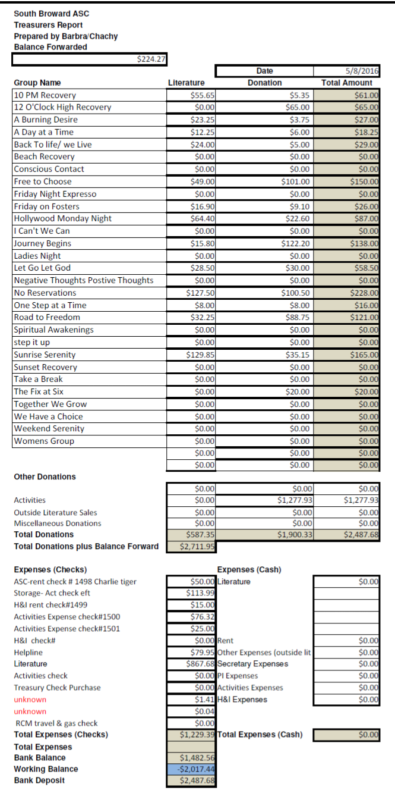
Policy Chair: James S – Everything is good with policy and up-to-date. I have been reading through Policy for Vice-Chair requirements since I know we need one. If I accept that position I would be covering Policy anyways so I am considering taking the Area Vice-Chair position. But basically I have been studying Policy. I am getting better at it but it is tough sometimes.
Literature Chair: Morgan – We are catching up on orders. We do not have enough of the ‘Welcome to NA’ IP. We have H&I orders filled. This month I was given an order for 900.00 and our balance is actually 867.68, so we are actually under the amount of the order that they gave me. Our home group donates more to help area out, so please encourage yours to help also. We do not have tri-plate medallions right now.

GSR’S – GROUPS MUST VOTE ON HIGHLIGHTED MOTIONS

NEW BUSINESS –

Nominations & Elections
Liz nominated James S for Area Vice-Chair

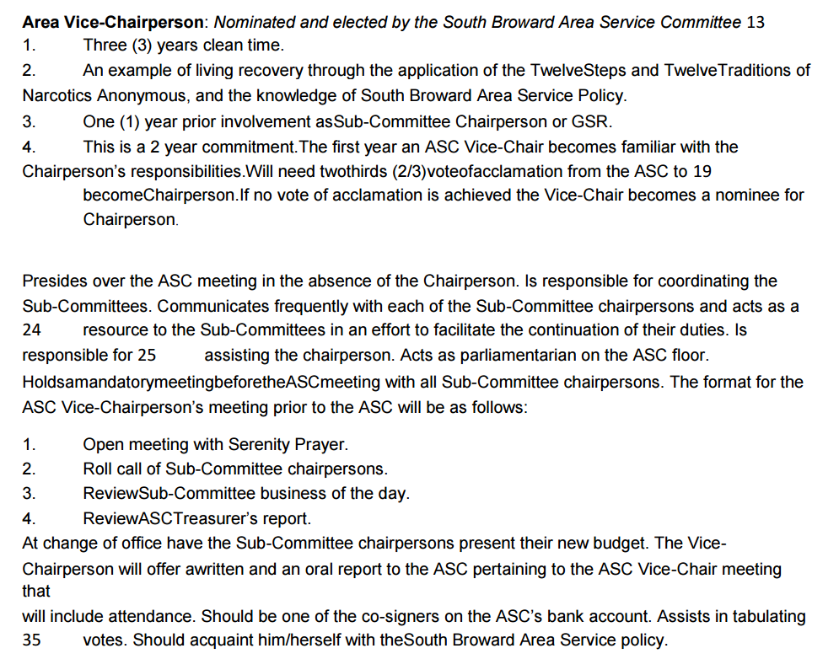

My clean date is 9/8/2002. I have multiple years of experience on Policy and Activities. I have only a little experience with Literature and Public Relations, but I know if those things come up, I have people close to me including my sponsor that is really good with that stuff that can help me. I have a sponsor who has a sponsor who has a sponsor. I have worked Steps and do as much service as I possibly can and I show up every chance that I get.

Mike nominates Rachel for Alternate Secretary

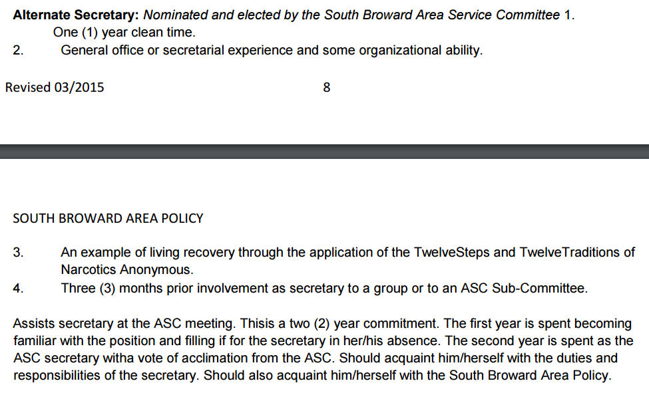

I will have 2 years clean tomorrow (5/9/2016). I have been the GSR for 14 months for my home group. I am committed to this program and to this commitment. I work in a law office and do office work so it is in the same realm of what is needed here.

Area Motions –
Motion 05-18-16 Maker: Greybook Second: Back to Life We Live

Motion Reads: To change Policy in 9C from “The Chairperson has a vote only in the case of a tie” to instead read as “The Chairperson has a vote only in the case of a tie except in matters of group conscience.”

Intent: For votes to more accurately reflect group conscience.

Regional Motions
Motion 04-03- 16 Maker: ADMIN Second: S. Dade

Motion Reads: This is a question for the groups of the South Florida Region; Do you want a regional convention in 2018?? Yes or No

Intent: The reason for this question is to get the conscience of out groups whether or not to move forward in planning a 2018 regional convention in lieu of the 2018 World
Convention being in Orlando (Within our Region) This will mean a lot of our members will be serving the World Convention and will be unable to serve on our regional convention committees as well as the impact on the attendance at the regional convention.

OLD BUSINESS -

Nominations & Elections –
Barry nominates Forest for PR/Helpline Chair
Qualifications: I have 9 1/2 years clean with 9 years on helpline. I’ve been helpline chair before. I have the willingness to serve and I have a sponsor who has a sponsor.
FOREST ELECTED AFTER MOTION WAS PASSED TO WAVE POLICY TO VOTE ON AREA FLOOR

Area Motions - none

Regional Motions - none
Motion to Close: Mike
Seconded: Mark

