Next ASC is Sunday May 8, 2016
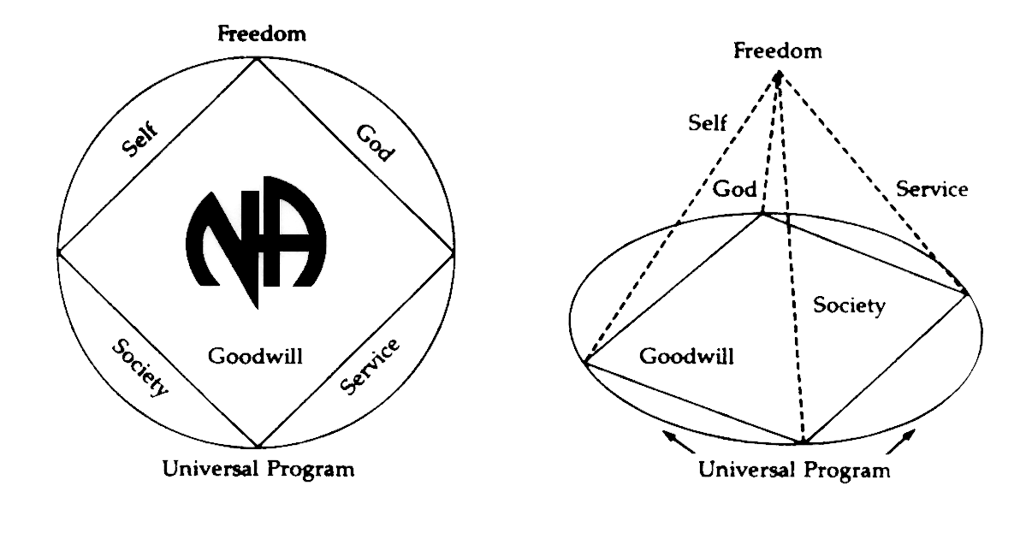
THERE WILL BE A
NEW GSR ORIENTATION BEGINNING AT 11:30am

PLEASE ANNOUNCE THE FOLLOWING AT YOUR MEETINGS:
WE NEED TRUSTED SERVANTS AT THE AREA LEVEL

VICE CHAIR
ALT SECRETARY
ACTIVITIES TREASURER
HELPLINE/PR CHAIR
NEWSLETTER CHAIR

Any questions or suggestions:
James W. (Chair): jrwashington954@gmail.com/954-274-1477
Barbara T. (Treasurer): tabaccob@comcast.net/954-448-1571
Sandy D. (Secretary): sdeen1124@gmail.com/954-253-7578

South Broward Area ASC Minutes
James opened the meeting at 12:00 pm with the Serenity Prayer.
Casey read the Twelve Traditions.
Ken read ASC Definition.

Open Forum- [All thoughts and opinions expressed in open forum are that of the individual and do NOT represent NA as a whole]

YoFrank – A motion came from the Board of Directors so that no one on the convention committee should get any free hotel rooms. We should not get free things for service, but other members go to do service, like regional and helpline members, who receive reimbursements. However, Board members who are working just as hard and are not being accommodated. I know I can’t change anyone’s mind here but I am going to region to try to change their mindset.

Casey – New GSR for 10pm Recovery at 4th Dimension.

Roll Call
Admin Committee | MAR | APR | MAY | Admin Committee | MAR | APR | MAY
Chair: James W  954-274-1477  Jrwashington954@gmail.com | X | X |  | H&I Chair: Duke S  954-931-7083  dukehlwd@yahoo.com | X | X
Vice Chair:  Open Position | O | O |  | Literature Chair: Morgan F  321-207-6054  Frankrebel2011@hotmail.com | X | X
Secretary: Sandy D  954-253-7578  Sdeen1124@gmail.com | X | X |  | Policy Chair: James S  754-204-5494  Southersjames122014@gmail.com | O | X
Alternate Secretary  Open Position | O | O |  | Activities Chair: Clint  954-614-2146  lynnbupps@gmail.com | X | X
Treasurer: Barbara T  954-448-1571  Tabaccob@comcast.net | X | X |  | Activities Treasurer:  Open Position | O | O
Alternate Treasurer: Horacio M  954-479-9447  Horacio.f.moreno@att.net | X | X |  | Helpline/PR Chair:  Open Position | O | O
RCM: Robert S  954-483-9147  Robertstuart5611@yahoo.com | X | X |  | Newsletter Chair:  Open Position | O | O
Alternate RCM: Liz S  754-208-7024  e.southers@outlook.com | O | X

GROUP | MAR | APR | MAY
1. Back to Life We Live | X | O
2. Beach Recovery | X | X
3. Burning Desire | X | O
4. Fix at Six | O | O
5. Free to Choose | X | O
6. Grey Book Group | X | X
7. Hollywood Monday Night | X | X
8. H.O.P.E. | X | O
9. I Can’t We Can | X | X
10. Journey Begins | X | X
11. Ladies Night | O | X
12. Let Go, Let God | X | X
13. No Rezervations | X | X
14. Negative Thoughts, Positive Reactions | O | X
15. One Step at a Time | X | X
16. Road to Freedom | X | O
17. Spiritual Awakenings | X | X
18. Step It Up | X | X
19. Sunrise Serenity | X | O
20. Take A Break | X | X
21. The Women’s Group | O | O
22. Together We Grow | X | X
23. We Have a Choice | X | X
24. 10 PM Recovery | O | X
25. 12 O’Clock High Group | X | X

Attendance Key: | X = Present | O = Absent
Three consecutive absences from one group will result in being deleted from roll call.
Quorum is Established at 15 (1/2 of 28+1)
Present 17 of 25 = Quorum Met

IV. Reading of the second to the last paragraph of Prefix (page xvi) of Basic Text completed by: Brian
V. Trusted Servants Presentations by: Max
VI. Acceptance of last month’s Minutes by: Ken and Rachel
VII. Administrative Reports:

ASC Chair Report: James W. – Barbara said we did not order literature last month and Morgan needed to send out the order. I approved the order because we had funds to cover it. We are looking for a Vice Chair. Please step up because I am out of here in August.

ASC Vice-Chair: OPEN POSITION

Secretary: Sandy D – My new email address is sbareasecretary@gmail.com

RCM: Robert S. – Thank all groups who participated in or car repot ballots. I am looking forward to region next weekend in mid coast in loving service.

Alternate RCM: Liz S. – No Report.

Activities Chair: Clint – Activities needs a Treasurer. This is urgent. I am temporarily doing both positions. We do not get support from our own Area. How do you want us to put Activities on when we are not supported by our own Area? We need help with the Anniversary BBQ. Anything I share is my opinion not that of all the Activities committee.
Check Requests for $700.00 BBQ
$30.00 One week rent for church
$116.50 misc. supplies
$846.50

H&I Chair: Duke –
Linda dropped of the flyers for the H&I Gratitude Dinner which is $5 a piece. It takes place June 11. We need to sell pre-sale tickets. This is the biggest event happening now. So please have your secretaries announce this. No new members last month with 5 open positions.
GSRS ANNOUNCE H&I OPENINGS AT YOUR MEETINGS

2 openings for Broward Girls’ Academy – No Clearance through BSO Required – Near Susan B off Pembroke Road

Opening for Hollywood Work Release – 1 day a month – Female with State Clearance

Openings for Star Program – South Florida State Hospital – Tues and Fri Nights

Openings at Broward County Jail – Men’s Side

Alternate Treasurer: Horacio M –

(See next page)

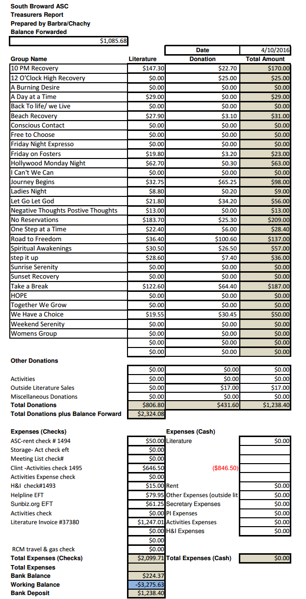
Policy Chair: James S – Policy report 4/10/16. I'm doing my best to learn what's in the policy package. If I mess anything up please correct me because that's how I learn. In loving service.
Literature Chair: Morgan – We are catching up on back orders and the orders that we have. This month we spent $1,247.01 and the area gave me a budget of $1200, which means we went over by $47.01. I am talking to my homegroup about donating more money to area. Maybe tell your homegroups not to place big orders so we can catch up.

Helpline/PR Report: Read by Area Secretary Sandy per Barry’s email –
OPEN FORUM:
Brian is announcing helpline at each meeting
New outside meeting at Frost Park Friday at 7:30 will be on new meeting list

NEW BUSINESS:
West Coast "Poster Day" ran into a few issues, these are being addressed by region chair
ROC will be moving its entire facility within the next month, meetings that are held there are invited to move with the church, but most are looking for new sites now and meeting lists will be amended as new information is obtained

Motion to vote Forest as chair for our committee with Tony as vice- chair and each accepted the responsibility

Motion to close by Forest, second by Dean

GSR’S – GROUPS MUST VOTE ON HIGHLIGHTED MOTIONS

NEW BUSINESS –

Nominations & Elections
Barry nominates Forest for PR/Helpline Chair
Qualifications: I have 9 1/2 years clean with 9 years on helpline. I’ve been helpline chair before. I have the willingness to serve and I have a sponsor who has a sponsor.
FOREST ELECTED AFTER MOTION WAS PASSED TO WAVE POLICY TO VOTE ON AREA FLOOR

Area Motions
None

Regional Motions
None

OLD BUSINESS -

Nominations & Elections - none

Area Motions
#03-16-01
Motion from Spiritual Awakenings Seconded by Journey Begins
To add to ASC Policy FORMAT OF AN AREA SERVICE MEETING
Add between item 2, Reading of Tradition & Before Item 3, Open forum.
Parents, please take responsibility for your children and for their safety. To allow the ASC to focus on our business, please do not allow your children to roam the building. We also ask if they become disruptive to remove them and come back when they are settled down.
Intent: To help resolve the issues that have come up during ASC meetings
PASSES

#03-16-02
Motion from Activities Seconded by Morgan F.
To change when Literature is handed out until after the meeting
Intent: So GSRs will stay to meet quorum for voting
FAILS

#03-16-03
Motion from Step It Up Seconded by Journey Begins
To bring back to groups to allow Area to discuss changing the time and/or date that Area meets. The time and/or date will be determined if this motion passes.
Intent: to see if more members will participate in Area service
PASSES

Regional Motions
Motion 12-05-15 Maker: ADMIN Second: Gulf Coast
Motion Reads: Page 41 sub section 10, Item VI
[SFRCNA Policy Change]
To Change From: No free complimentary rooms shall be given to the host committee or the convention board, with the exception of those members needing to be at the convention one day prior to or following the convention, to be determined by the convention board in conjunction with the host committee.
To: No rooms or meal shall be accepted by any board member or host committee member.
Intent of Motion: To have a more clearly defined relationship and boundaries set for convention committees and host hotels.
FAILS

Motion 02-07-16 Maker: RD Second: Shark Coast
Motion Reads: To table back to the areas motion #12-04-15 that was passed at our last RSC.
Intent: To get direct conscience from our areas on the creation of a Multi-Regional Shared Services Adhoc Committee.
PASSES

Motion 12-15-04 Maker: RD Second: North Dade
Motion Reads: To create a multi-regional shared services ad-hoc committee consisting of 4 members from each or the three regions serving the state of Florida. Three of the four members from each of the regions will consist on one delegate, the PR chair / coordinator, webmaster and another to be determined by each of the particular regions. This committee would meet by webinar.
Intent of Motion: This motion is already going back to Florida Region and will be brought up in the Alabama / NW Florida Region this month.
The purpose of this committee/workgroup will be to help avoid some of the problems with the services we are sharing & looking for new ways to improve shared services.
PASSES

Motion 02-01-16
Maker: SFRNCA Board of Directors Second: N. Dade
Motion Reads: To approve SFRCNA 2016 Budget
Intent: To allow BOD to move forward with convention planning.
Financial Impact: $74,037
Proposed 2016 Budget:
FAILS
Motion to Close: Mike
Seconded: Rachel

