South Broward Area Service

Date: December 9, 2018 Next ASC: Theoretically, January 13, 2019 at 10:00am

- Opening 10:05 AM
- Chair read Serenity Prayer
- Tracey read 12 Traditions
- Laura read Definition of an ASC
- Chair called for check requests and/or motions called to be turned in.

- Open Forum
[All thoughts and opinions expressed in open forum are that of the individual and do NOT represent NA as a whole]
- Bruce – Host convention has hotel, Harbor Beach Hotel. Fundraiser today.
- Laura – Activities has slots available for the Christmas and New Years 24-hour rooms
- Larry – Will be at the 24-hour room, please contact if needed

- Introduce of New GSRs: Bruce, alt-GSR for Conscience Contact

B. Collect Zoom Zooms – No report

3. Roll Call Present = P Absent = A Open = O
A. Administrative Committee
B. Subcommittees
C. Groups

Admin Committee | Oct. | Nov. | Dec. | Admin Committee | Oct. | Nov. | Dec.
Chair: |  |  |  | H&I Chair:
Yo Frank Klein  Yofrank@bellsouth.net | P | P | P | open | A
Vice Chair: |  |  |  | Literature Chair:
Prescott K.  Hawaiiguy73@gmail.com | P | P | P | Linda S.  Linnie91557@yahoo.com | P | P | P
Secretary: |  |  |  | Policy Chair:
Sandi  Sandi883@aol.com | P | P | P | Pam R.  lpnpregan@aol.com | A | P | P
Alternate Secretary: |  |  |  | Activities Chair:
open |  |  |  | Ralph | P | P | P
Treasurer: |  |  |  | Activities Treasurer:
Adrian  kasen31@gmail.com | P | A | P | Chachy  Horacio.f.moneno@gmail.com | P | P | P
Alternate Treasurer: |  |  |  | Helpline/PR Chair:
open |  |  |  | Sue  sewf@bellsouth.net  sbapublications@gmail.com | P | P | P
Alternate RCM: |  |  |  | RCM:
Robert S.  Robertstuart5611@yahoo.com | P | P | P | Joanne G.  Joanngna2004@gmail.com | P | P | A

Three consecutive absences from one group will result in being removed from roll call.
- Groups added: West on Wednesday
- Groups removed: 10PM Recovery
Quorum is Established at (1/2 of 23 + 1) =13
Present 17 of 23 = Quorum Met

# | Group | Oct. | Nov. | Dec.
1 | West on Wednesday sewf@bellsouth.net |  |  | P
2 | 12 O’clock High Group dgree714@bellsouth.net | P | P | P
3 | Tuesday Night Steps na.wendel0218@gmail.com | A | P | A
4 | A Day at a Time lpnpregan@aol.com | A | P | P
5 | Conscious Contact Pkelner.realestate@gmail.com | A | P | P
6 | Back to Life We Live jasonscfx@gmail.com | P | P | P
7 | Bitter Ends 754-245-1339.ly@gmail.com | P | P | P
8 | Sunrise Serenity jrwashington954@gmail.com | P | P | P
9 | A Burning Desire eric@dbamericas.com | A | P | A
10 | Veterans in Recovery Mkeels@broward.org | P | A | P
11 | Take a Break arrasrubio@yahoo.com | P | P | P
12 | Fridays on Foster frankt@dockproducts.com | P | P | P
13 | Hollywood Monday Night kcar747@icloud.com | P | A | P
14 | One step at a Time yorker627@aol.com | A | A | P
15 | I Can’t We Can Jaswaltermi@aol.com | P | P | A
16 | Free to choose – Betty | A | P | A
17 | The Journey Begins horacio.f.moneno@gmail.com | P | P | P
18 | Negative Thoughts, Positive Reactions | P | P | P
19 | No Rezervations frank.amfi@gmail.com | P | A | A
20 | Women’s Group jbillie99@bellsouth.net | P | P | P
21 | Road to Freedom yamidiazit@gmail.com | P | A | P
22 | Spiritual Awakenings philkas@comcast.net | P | P | P
23 | Step It Up tonyvav99@gmail.com | P | P | P

4. Reading the second to last paragraph of Prefix (Page XXVI) of Basic Text – John

5. Trusted Servants Presentation – Barry

6. Acceptance/Corrections of last month’s Minutes: M/S/C Conscience Contact/Road to Freedom “Accept minutes”.

7. Administrative Reports

ASC Chair:

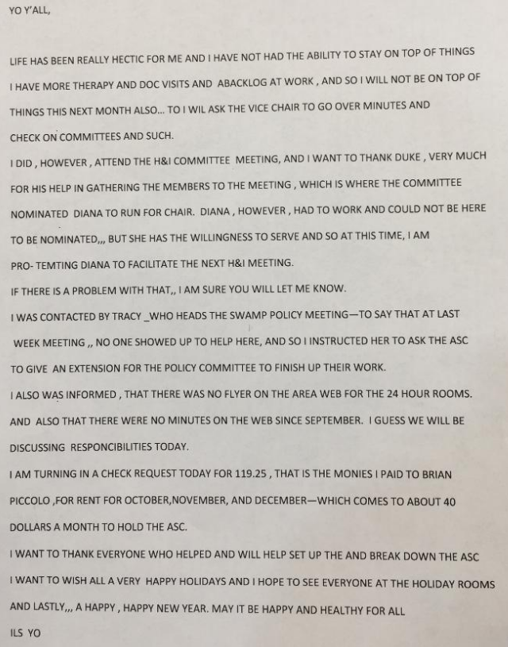
ASC Vice-Chair:
Greetings South Broward area NA family,

And Merry Christmas to all, as truly if you're reading this.. then each of you has received one of our greatest gifts in life... the gift of recovery one day at a time... which is why so many of us continue to participate and being of service to the South Broward area in gratitude for that gift

As we have not had a chair or any reports at the sbac from h&i for some time I attended the November 22nd hni subcommittee meeting. After having contacted as many people as possible that I was aware of to attend that were participating in bringing meetings into facilities. I want to give all thanks to Duke who stepped up and basically contacted everyone on the list that he had and chaired the meeting and took care of the h&i business. A person willing to bees a chair has stepped up however they are not able to be here for nomination today and it was agreed that they would serve and were elected as Vice Chair by the h&i committee so they can serve until formally being voted in as chair. More details will be presented when I give the report for H & I. Meetings being covered was handled positions were dealt with and will be announced during h&i report and I'm very happy to say reduce help h&i will be represented at sbac and is continuing to fulfill its primary purpose to carry the message into the facilities as currently listed again as your Vice chair Please be aware that there are two or three meetings that still need to be filled and I would encourage you to contact Duke if you're willing to fulfill those 1 hour commitments during the week as mentioned earlier out of gratitude for this wonderful gift we know as recovery. I will be giving the hni report today as acting chair as both both Duke and the elected vice-chair are not able to attend vice-chair had to work and Duke is out of town. Thank you for allowing me to serve. ILS Prescott k

Secretary: No submitted report

RCM: No submitted report

Alternate RCM:
Looking forward to carrying our area votes to region next Sunday.
In loving service
Robert S

8. Subcommittee Reports

Activities Chair: No submitted report

Activities Treasurer: No submitted report

Helpline/Public Relations Chair:
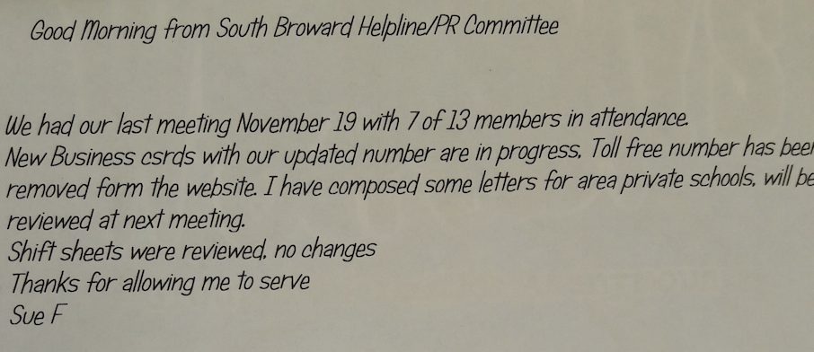

H&I Chair: open

Policy Chair:
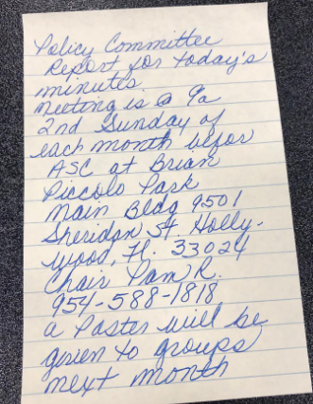

Literature Chair: No submitted report
Swamp – No submitted report
Treasurers Report: No submitted report

Nominations:
Alt. Secretary: No nominations
Alternate Treasurer: No nominations.
H&I Chair: No nominations.

Old Business:
MOTION#: 11/11/18 - 1 MOTION PASSES 16/0/0
MOTION READS: Approve Activities 2019 Budget
MAKER: RCM
SECOND: Back to Life
INTENT: Have monies needed for events

MOTION#: 10-18-01 MOTION FAILS 1/11/1
MOTION READS: To send a letter to NAWS stating “South Florida Region would like to reaffirm out unity with the fellowship of NA & NAWS. South Florida Region fully embraces our current library of recover literature and believes it’s the best ever written. We appreciate and value our trusted servants and recognize the exceptional job NAWS has done in supporting & growing our fellowship.”
MAKER: Shark Coast
SECOND: Beach and Bay
INTENT: To affirm out unity.

MOTION#: 10-18-02 MOTION PASSES 14/0/1
MOTION READS: To add to policy Page 6 Section I 4
Old: Any new area that comes to RSC may start voting and be recognized that day.
New: Any NA area is welcome to join SFR after an area is voted into SFR by simple majority and may then start voting and be recognized.
MAKER: Admin
SECOND: Mid Coast
INTENT: To have clarification as to what an area is and how an area is seated.

MOTION#: 10-18-05 MOTION PASSES 15/0/0
MOTION READS: H & I Budget for 2019
MAKER: H & I
SECOND: East Central Florida
INTENT: To conduct operating cash. The budget hasn’t been revised in 3 years to my knowledge. As a Chair & Vice Chair we travel to help areas and do book drives. This is the reason for the ASC Functions & Events.

MOTION#: 10-18-06 MOTION PASSES 14/2/0
MOTION READS: To review and vote on Public Relations 2019 budget proposal.
Financial Impact: $22,800 up $550 from 2018
MAKER: PR
SECOND: East Central
INTENT: To conduct business for the upcoming fiscal year

MOTION#: 10-18-07 MOTION PASSES 12/2/1
MOTION READS: To approve proposed 2019 ADMIN Budget
Financial Impact: $34,395
MAKER: Admin
SECOND: Mid Coast
INTENT: Have an operating budget for 2019

MOTION#: 10-18-09 MOTION PASSES 10/4/0
MOTION READS: That the newsletter has an annual budget of $900 to be allotted bi-monthly at the RSC. Reimbursement request max increase proportionately if extra room nights are required or hotel expenses exceed $150.
Financial Impact: $900
MAKER: Newsletter
SECOND: Mid Coast
INTENT: To ensure that the newsletter chairperson is financially able to attend the RSC.

MOTION#: 10-18-11 MOTION PASSES 12/1/0
MOTION READS: To Approve Lit Review Budget 2019 – Proposed
Financial impact - $1500
MAKER: Literature Review
SECOND: Mid Coast
INTENT: To have operating budget for 2019

REGIONAL NOMINATIONS -
Pete S. – BOD 12/0/0
Joanne – BOD 13/1/0
Rick D – BOD 7/4/2
NEW BUSINESS:

MOTION#: 12-01 Motion Passes 12/1/0
MOTION READS: Swamp Recovery would like an extension of time to have a completed policy to present to area. Please give us until February’s ASC.
MAKER: One Step at a Time
SECOND: Back to Life
INTENT: to finalize policy to allow time to finalize the policy of specifics regarding swamp recovery.

MOTION#: 12-02 Motion Ruled Out of Order
MOTION READS: That Swamp Recovery submit the policy which they have already. Changes can be made at a later time
MAKER: The Journey Begins
SECOND: Back to Life
INTENT: to finalize policy to allow time to finalize the policy of specifics regarding swamp recovery.

MOTION#: 12-01 Motion to groups
MOTION READS: To raise prudent reserve to $7,000.
MAKER: Admin
SECOND: Journey Begins
INTENT: to cover projected expenses for Swamp Recovery
Cons – money hording; there is a fund flow
Pros – South Broward agreed to have Swamp, now we need to pay for it; functions this size require money

The meeting adjourned at 11:30ish.

Please contact Admin Committee members if you have any questions or suggestions:

YO Frank Klein (Chair): Yofrank@bellsouth.net
Prescott K (Vice Chair): Hawaiiguy73@gmail.com
Adrian (Treasurer): kasen31@gmail.com
Sandi (Secretary): SBAreaSecretary@gmail.com (sandi883@aol.com)
Robert S. (RCM): RobertStuart5611@yahoo.com
Joann G. (Alt RCM): JoannGna2004@gmail.com
Pam R. (Policy Chair) lpnpregan@aol.com

AREA MOTIONS GOING BACK TO GROUPS TO BE VOTED ON:

MOTION#: 12-01 Motion to groups
MOTION READS: To raise prudent reserve to $7,000.
MAKER: Admin
SECOND: Journey Begins
INTENT: to cover projected expenses for Swamp Recovery
Cons – money hording; there is a fund flow
Pros – South Broward agreed to have Swamp, now we need to pay for it; functions this size require money

